Vol. 26 No.2 Sign Post Sept. 2018
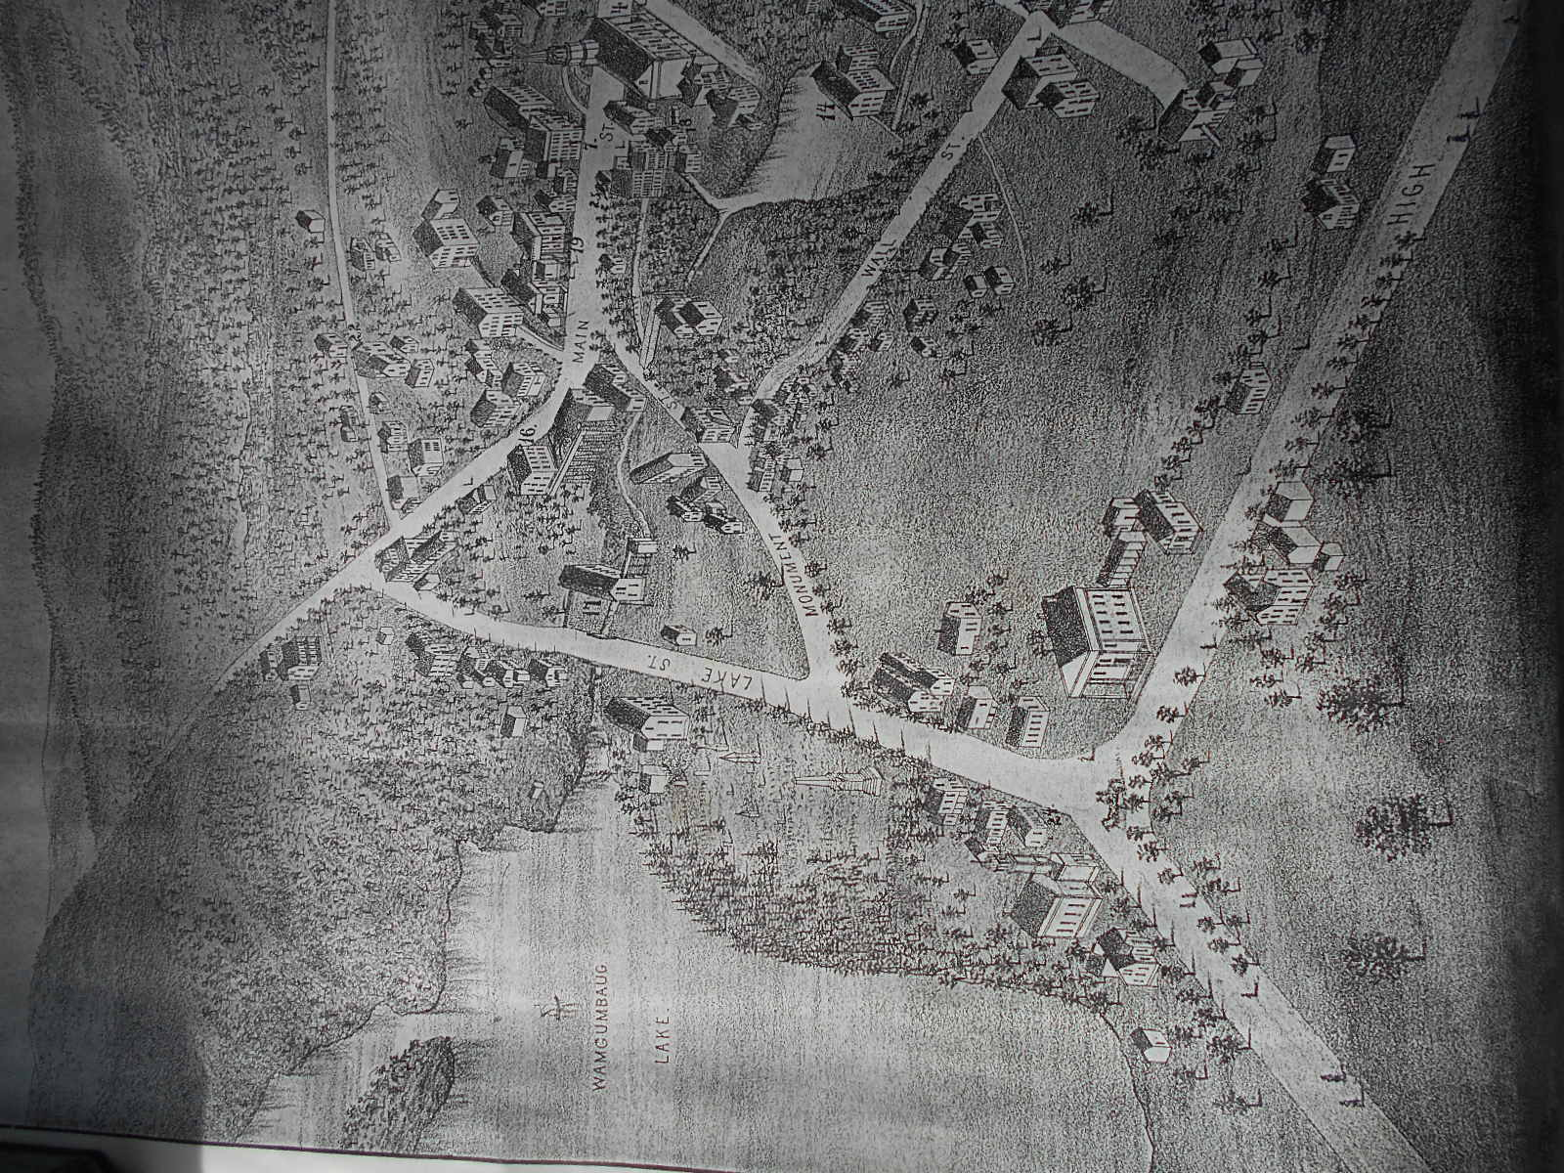
The Old Center of Coventry
There is a lovely quiet neighborhood that happens to be at the South end of Coventry Lake, Lake Wangumbaug, and so it includes Patriots Park and the Town Green where we honor the men and women who have served in the military from this town for more than 300 years. Nearby is the Nathan Hale Cemetery. It’s a peaceful place that lends itself to reflection. Most Coventry residents probably don’t realize this once was the busy center of town. Coventry’s first church was built on what today is High St. in 1715. The first parsonage, the home of the Rev. Joseph and Esther Meacham stood on what today we call the Monument Green. The first school was built nearby, and the first Gristmill in town was built near the outlet of the Mill Brook from the Lake. Many of the first settlers in town built their houses around this Green. One of those families was the Rose family and the house at the top of the Green served as the Rose Tavern and Store for many years. Most of the buildings mentioned can be seen in the 1880 Birdseye map of Coventry above along with the Methodist Church that was built near the entrance to Patriots Park perhaps in 1839, and later used by the Catholic Church.
Fanny Rose Bennett was born here in 1859 the daughter of Richard H. and Sarah Manning Rose and she lived in this part of town for most, if not all of her life. We believe that near the end of her life she asked that the family Archive of documents, letters and Account Books be put in the hands of an organization that would preserve and share them. The 1st Coventry Historical Society was chartered and organized in 1945. This group did not survive long, perhaps because of the declining health of its founding members and officers. Boxes of Archival materials collected by this group were stored in the Vault of the town’s first Town Hall, the 1876 building we know today as the Visitor’s Center. Years later a 2nd Coventry Historical Society was chartered and organized in 1962 with the strong support of town residents. The stored Archives were first transferred to the Sprague House our first Headquarters and then to Strong Porter Museum.
CHS has been participating this year in a program sponsored by Ct State Library & the Conservation Connection. We are creating “Finding Aids”, which are outline descriptions of our collections to be uploaded to Connecticut Archives Online (COA). We have completed the first 3, and the 4th will be the Rose Family Collection. These papers and Account Books have opened up a window on the lives of this family and all the activity at the Old Center of Coventry.
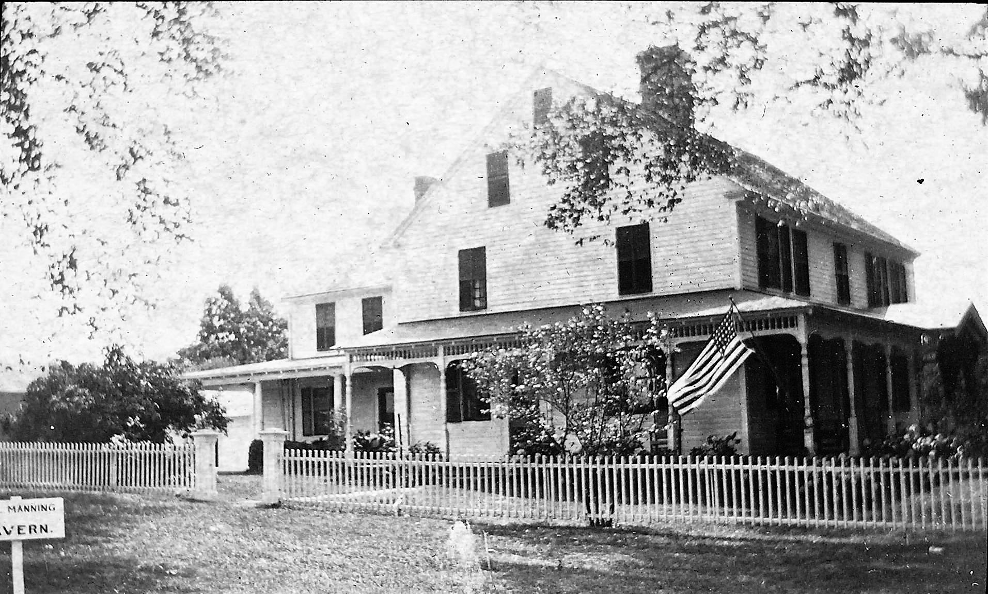
The Rose Tavern as it looked in 1912. It served as a Tavern until about 1844.
We will allow the spirit of Fanny Rose Bennett to lead us on two walks around this area on Oct 26th. The first at 1:00 PM will be listed on this year’s TLGV Walktober Calendar. The second walk will begin at 3PM and will be a Lantern Tour for members and their friends. Fanny would have seen many changes during her lifetime. She would have remembered services at the old Church on the Hill, and the day it burned to the ground. Town meetings and elections were held in the basement of that church for many years, and festive days they were, rivaled by Training Days when the Militia gathered to drill on the green in front of the Rose Tavern. Fanny’s father and grandfather served as officers, and would have issued orders for the men to meet at a certain day and time on the “Old Training Ground”. The Tavern served the Town in many ways. Generations of the Rose family served as Town Clerks, Tax Collectors, Probate Judges, and Justices of the Peace among other local offices. You came to the Tavern to pay your taxes, settle estates, register deeds, births, marriages and deaths, sign up for the Militia, collect your mail, and perhaps your newspaper, make your purchases at the Rose Store and stop in the Tap Room for a meal or a drink while you shared local news and talk over the larger news stories of the day, then perhaps at last turn to retelling old stories. Fanny would have undoubtedly heard many stories of this place and its people as she grew up, and we will share some we have heard thanks to Fanny and others who have helped to preserve Coventry History through their donations, and support.
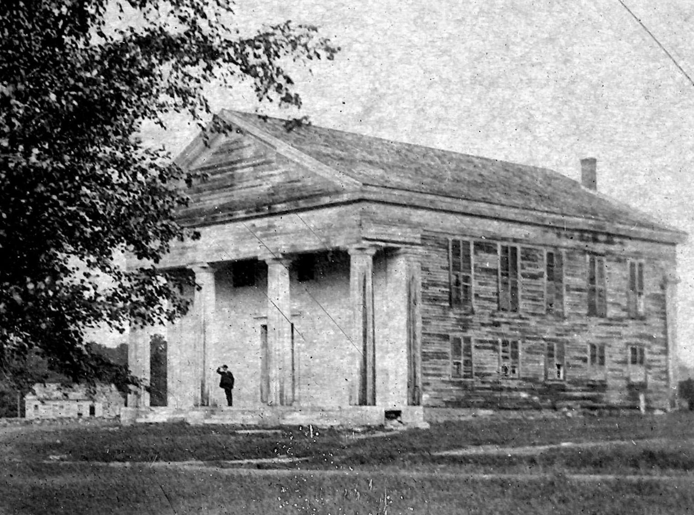
First Church or Meeting House built 1768-71 on High St. (Photo by Charles G. Coombs) The congregation split in 1848. The group that left built the Church in the Village. The group that stayed with the old church was not able to maintain it. The steeple came down in 1866, the church burned in 1897.
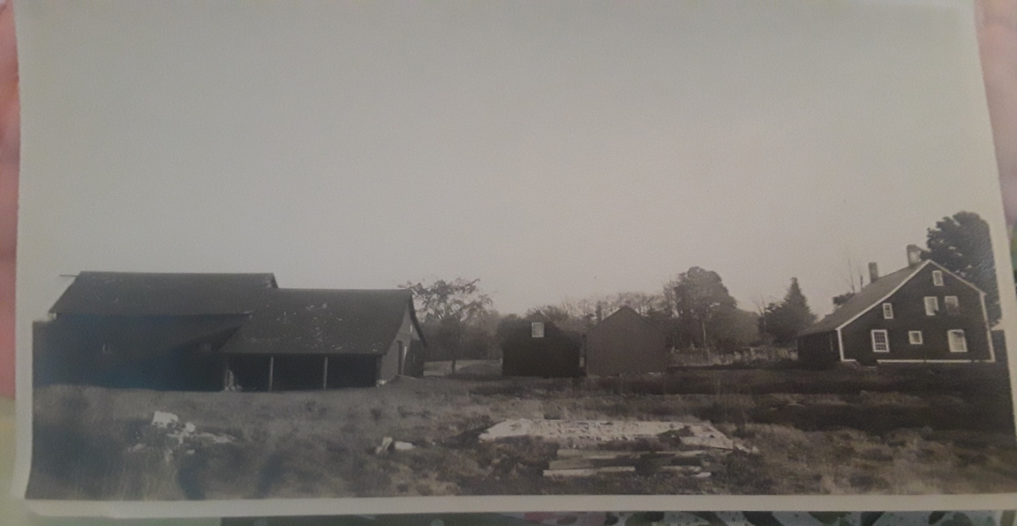
This photo of Strong Porter House was sent to us by Wendy Spagnuolo (Sam Hall was an Uncle) was taken by George Dudley Seymour. He writes on the back,”Restored to substantially its original form in 1926-27 by Messrs. Hall & Seymour.” For more on Sam Hall see below.
Our Village & Mill Walk will take place on Oct. 7th starting from the Welles Agency parking lots at 1PM. Sponsored by The Last Green Valley.
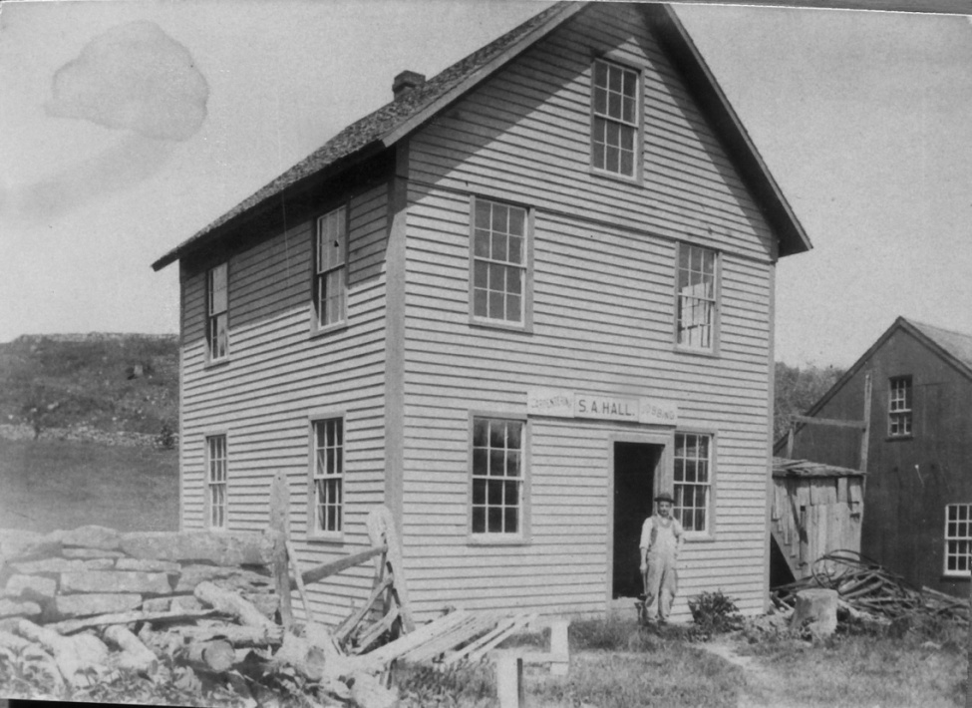
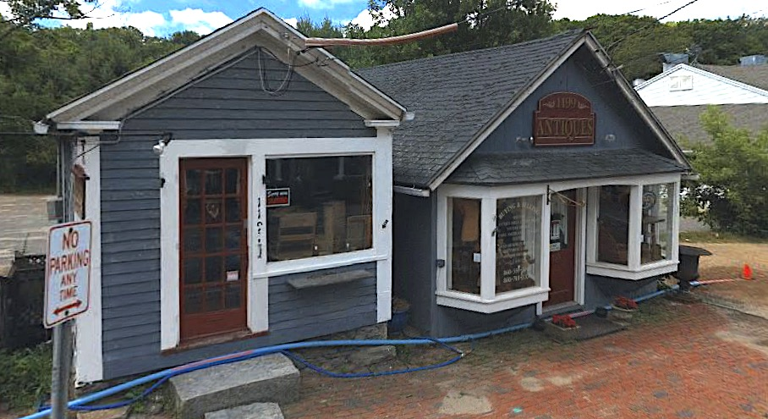
Have you wondered about the two buildings above as you drive by? We’ve learned some new and interesting facts! Sam Hall, standing in the doorway of his Carpentry Shop to the left (C.G.Coombs photo Don Aitkin Collection) played a role in the small buildings above in the construction and restoration of many buildings in town. He was born 1861 in England. His father Erastus was a carpenter in Coventry 1870. Learn more Oct. 7th.
