**November 2015**

**Volume 23, Issue 1**

Sign Post

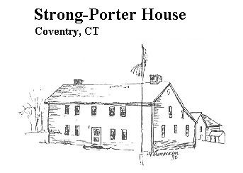 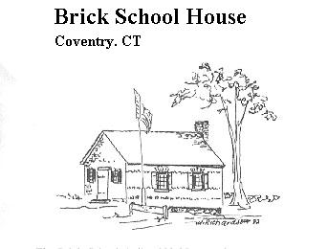

Wright’s Mills on the Skungamaug

**In march of 1726, the Town of Coventry granted 30 acres of land to Lazarus Manley in exchange for his agreement to build a saw mill on “the great falls of the Skungamaug River”, and to build a grist mill when sixteen families are settled nearby. Manley sold to Daniel Badger who fulfilled the agreement, and by 1734, a small dam was built and is mentioned in a 1756 deed.**

**The site is owned by several people in the early 1700’s, and in 1762, Elijah Wright, from Lebanon, at age 32 acquires rights to the mill site. By 1799 Elijah’s sons Elijah Jr. and Roswell own the site which includes a saw, grist and fulling mill. A new dam is built in 1808 after a major flood, and a substantial stone dam is built in 1844.**

**The last remaining mill site owner by the name of Wright was Harvey Wright, Roswell’s third son who sold the property in 1877, which still contained the three mills mentioned above. The 1870 Federal Census of Industry notes the site producing $49,000 worth of cloth and a saw mill producing $12,000 of lumber, both using water power of 46HP, and a grist mill using 20HP of power.**

**By 1880 a more efficient water turbine has been installed by the owner, Jared Loomis, and he is still operating the grist mill, producing 93,000 pounds of corn meal and 167,000 pounds of feed. It is not known how long the mill operated, though it changed hands frequently and there was a tax listing in 1918 for a “mill” owned by Henry Osborn. There is some evidence of a cider mill operating on the site adjacent to Bishop Lane in the early 1900’s.**

**In 1929 the site has a sprawling dilapidated mill house near the road bridge and several old stone**

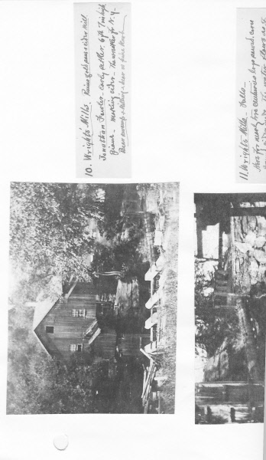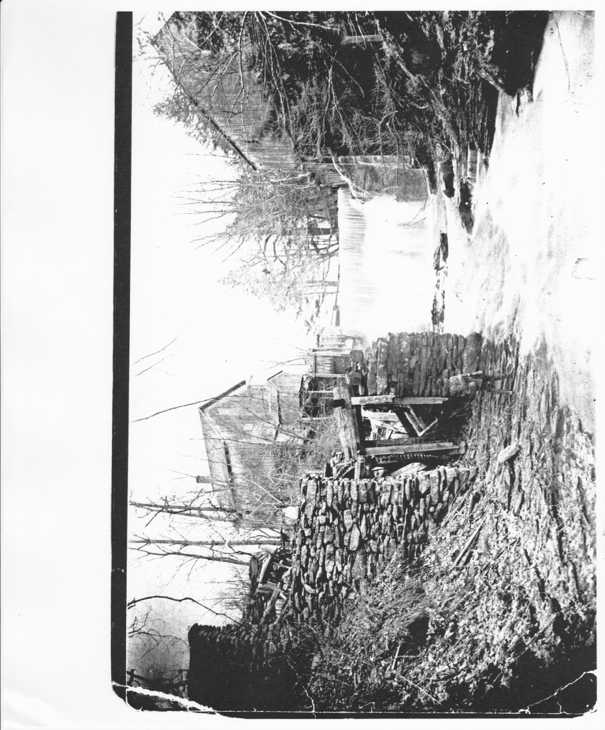 **SignPost page 2**

**foundations. It is purchased by E.LeRoy Gardner, a power company owner from Massachusetts. Upon his retirement he dismantled his stone house in Massachusetts and rebuilt it on this site, a process of some eight years, in which “it turned into an altogether different sort of house. It became a castle”. He installed a 17Kw D.C. electric generator for heat and light. He therefore weathered the hurricane of 1938 rather well, though his falls saw all sorts of debris including large trees and sheds during the hurricane.**

**In 1949, Gardner’s estate sold the property to Ralph McLeod, a maintenance supervisor at Pratt & Whitney Aircraft. He restored the mill building, built a stone generating plant and installed a 20-foot metal, overshot water wheel, all of which exist today. He installed a 30 Kw A.C. generator and a 24” penstock to serve the water wheel. He also surfaced the wheel with asphalt.**

**In 1970, the site was purchased by Jack and Roberta Bynes who refurbished the mill building into a dentist office and retail store.**

**..Many thank to those who Volunteered..**

**Bill Reale - for leading the team on Sundays at the Museum and for great lawn maintenance**

**Jim Sposito - for great work on building maintenance**

**Jim Rau – for technical help and equipment loans**

**Bill Jobbagy, Jim Wicks, Dick Symonds and Doug Bynes – for sharing their knowledge with us at our Wright’s Mills Walktober event**

**..Special Thanks..**

**To the whole Bynes family for making us welcome at their home, the site of the historic Wright’s Mills , the Great Falls of the Skungamaug River, and Gardner’s Castle**

**Finally a word of thanks to author Stephen Birmingham for giving us permission to reprint his memoir “My Grandfather’s Castle”. Copies are available, $6 to members $8 to non members, $2 for postage, call Sue Way (860 712 4278).**



-MANY THANKS TO ALL OUR VOLUNTEERS WHO HELPED TO MAKE OUR 2015 EVENTS AS SUCCESSFUL AS THEY WERE.

**Above: Steamer Launch at Lake Wangumbaug**

**Left: Newspaper advertisement for building lots on Lake Wangumbaug, $99.00 and up.**

#### Coventry Historical Society

P.O. Box 534

Coventry, Connecticut 06238

**Phone:**

860.742.9025

**E-Mail:**

[info@ctcoventryhistoricalsociety.org](mailto:%7Cinfo@CTCoventryhistoricalsociety.org)

The Coventry Historical Society Web Site is located at:

[www.ctcoventryhistoricalsociety.org](http://www.ctcoventryhistoricalsociety.org)

**Please visit our Facebook Page**

**New Executive Board 2015-6**

**President………**Jim Murphy

860-742-3054

[irishbrit0471@att.net](mailto:irishbrit0471@att.net)

**Vice President**…. Susan Way 860-712-4278 [susanrway@gmail.com](mailto:susanrway@gmail.com)

**Treasurer………..**Milton Natusch

860-465-9437

**Archivist…………** Susan Way

**Secretary…….**JoAnn Aitken

**Past President...**Pat Natusch

860-465-9437

**Members at Large**

Rachel Dawkins

Jim Wicks…….Maintenance

Carol North

Executive Board Meetings are held on

the second Thursday of every month, 7:30 pm at the Strong-Porter house. All are welcome.

Maintenance and Archives work parties often held on Wednesdays and Saturdays.

*Coventry Historical Society*

*P. O. Box 534*

*Coventry, CT 06238*

**Become a Member**

**Return your membership form today**

If you aren’t already a member of the Coventry Historical Society, please consider joining now, and join us at our Christmas party December , at :00 PM

This is a Potluck Meal. Last names beginning with A-M bring a salad or Dessert, N-Z a Main Dish.



**\*Christmas Party\***