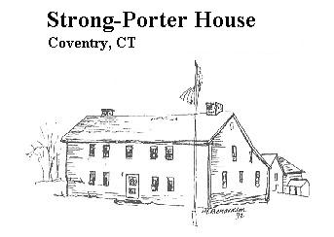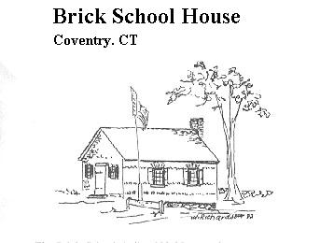
March 2016
Volume 24, Issue 1

Sign Post

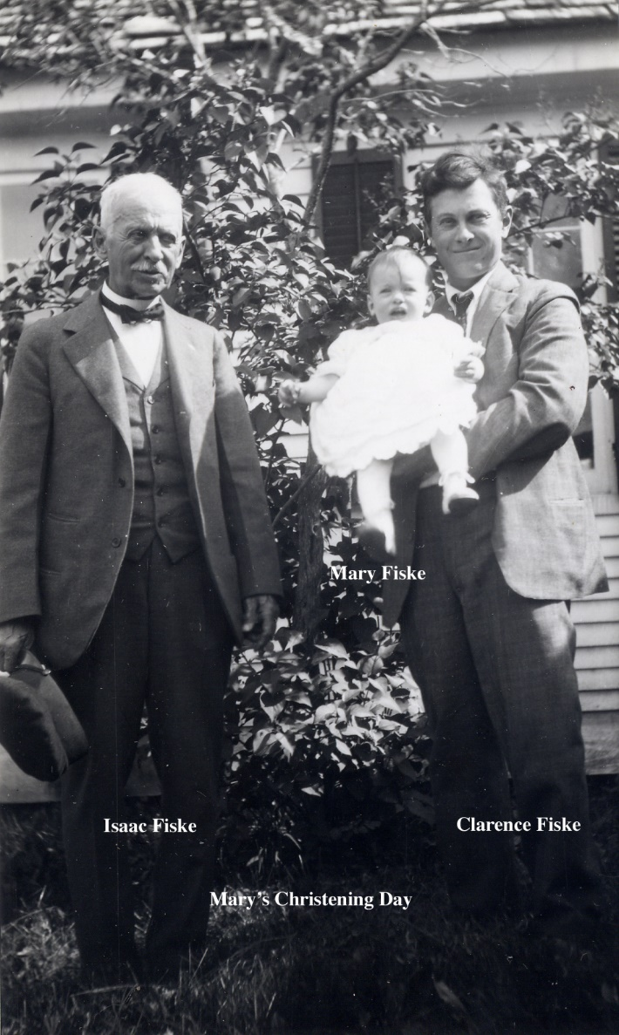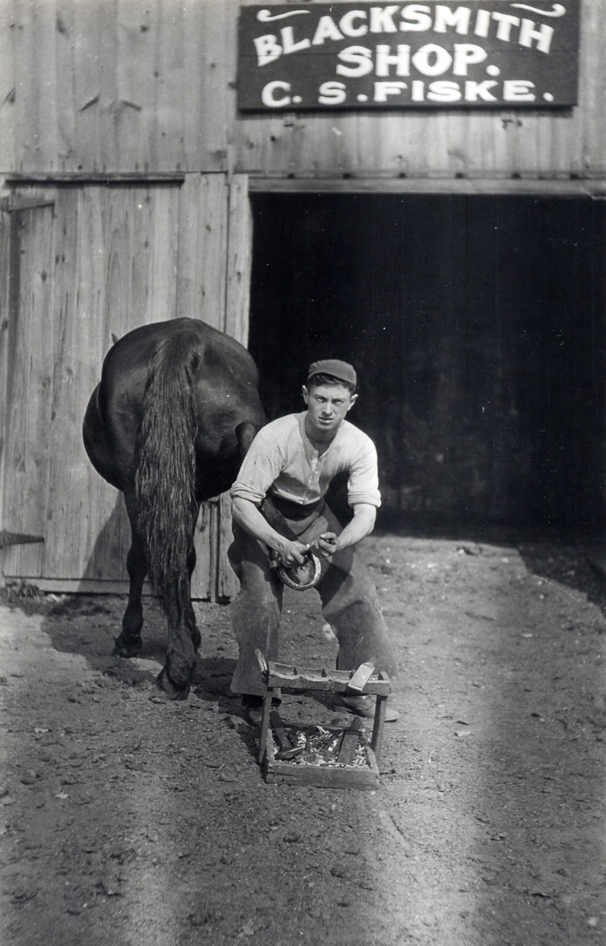
Dr. Isaac P. Fiske and his son Clarence S. Fiske
Isaac Parson Fiske was born in Marlborough, CT in 1852. He attended Yale College 1872-3 and N.Y.U. 1875-6 where he received his medical degree. He was married four times his first 3 wives dying at a young age. To Isaac and his second wife Mary Staunton Fiske was born Clarence Staunton Fiske in 1895 in Southington. The family moved to Coventry in 1905 and purchased the old Pomeroy Tavern house at #1804 Boston Tnpk. The house served as his home, office and as the post office.
Clarence Fiske was 10 years old when they moved to Coventry, and as a young man learned the skills of a blacksmith. There may have been a working blacksmith shop in the Pomeroy Tavern Carriage house when they moved there. By the age of 21 Clarence had established his own business there as seen above.
In 1917 he married Annie Schell daughter of Charles H. and Annie (Barnes) Schell who lived at 305 Brewster St. She was also sister to Charles G., Henry and Zoejte Schell who married Arthur Vinton. Clarence and Annie had one daughter Mary L. Fiske born July 8, 1922.
In 1918 Clarence and Annie bought the house at 44 Stage Rd. (best known today as the Glenney house) and built a shop between the house and the Grange Hall. Clarence expanded his business, built wooden sleds and shod horses. This was an era in which men trained as blacksmiths learned to become mechanics and being skilled in working metal might turn their attention to the future in transportation. He took on a partner Wenzel Augston and began building truck bodies.

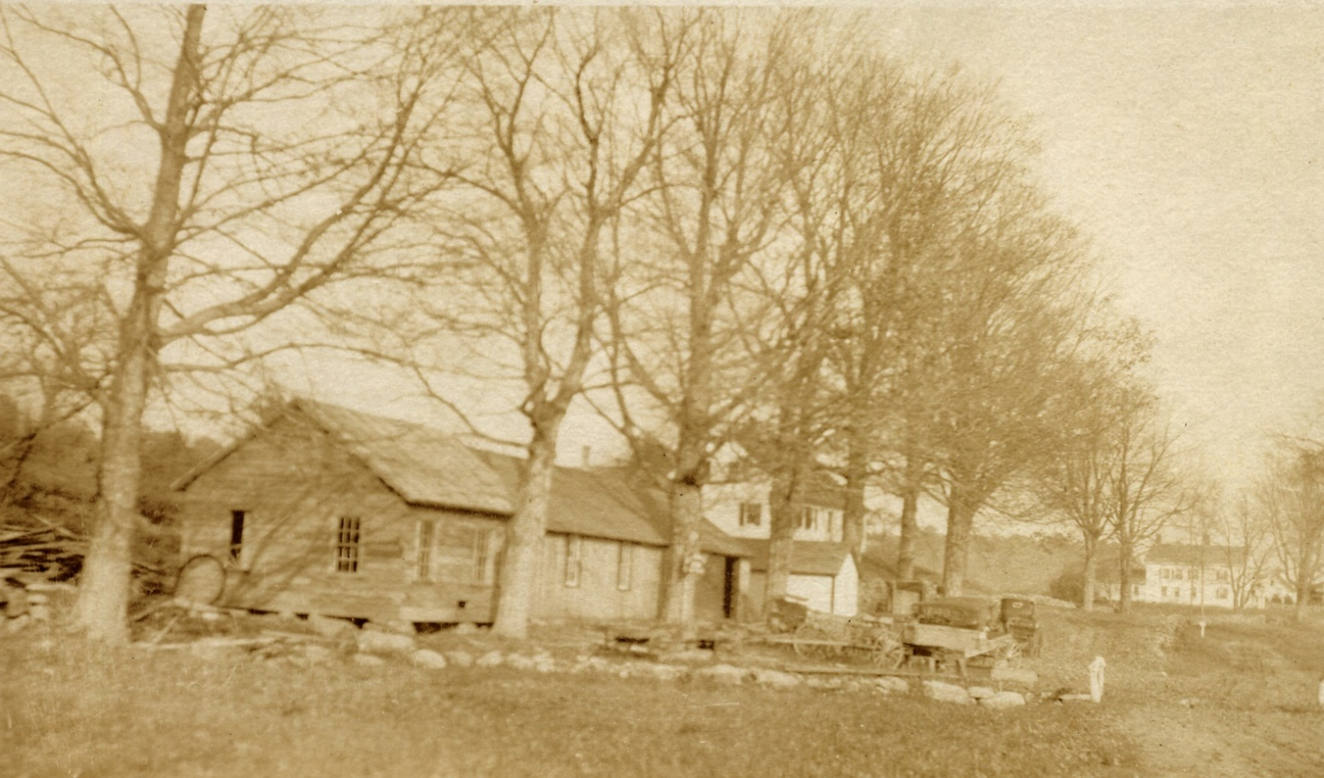

In these pictures taken on Stage Rd. they are a happy and enthusiastic family, however life changed in an instant when Clarence took a blow to the head from a horse’s hoof, a constant danger to people who worked with large farm animals. Clarence died as a result of that accident in 1933 at the age of 37. His father had died just 9 months earlier and Annie’s father in 1931. Annie inherited many responsibilities. She had the shop moved around the corner where it became Vinton’s garage and later Vinton’s Store. She had the building at 70/72 Stage Rd. converted into a two family house and sold. 44 Stage Rd. was sold in 1933. Annie married Clarence’s partner Wenzel Augston and they moved to Florida with her daughter Mary. [ below- C.H.Schell, Wenzel Augston, Mary, Clarence and Annie Fiske]

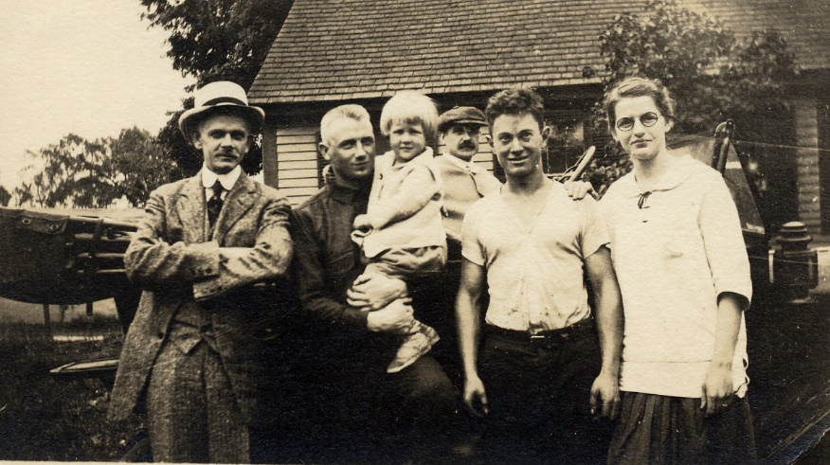
It was Mary’s grandson Larry Bruce who passed these photos on to his cousin Dave Hayden. Dave Hayden’s Grandfather Charles G. Schell was Annie Fiske’s brother, and it was his questions sent to us about the Schell farm on Brewster St. that resulted in the gift of 165 photos of the Schell, Fiske and Vinton homes and families from Dave Hayden. Which leads to our announcement of a slide show that we are calling …………………………………………………written by Sue Way research by Bill Jobbagy
An Early 20th Century North Coventry Picture Show
Will be presented by The Coventry Historical Society on March 17th at the 2nd Church Community Center at 6:30 PM. It’s our annual “Stew & Story” . A variety of stews, desserts and beverages will be served. Please bring a mug or a bowl and a spoon, and call for a reservation so we know how much stew to make- $8.00 for members $10.00 all others, children negotiable . Longtime residents are invited to bring a few North Coventry pictures of their own from this era and to join in the story telling.
Brick School Program says goodbye to Ginney and Gary Dilk. After 11 years developing and running programs at our Brick School House at the corner of Merrow Rd. and Goose Lane, and maintaining the property. Ginney and Gary Dilk are saying goodbye and planning to move to Tennessee. CHS would like to extend our thanks for years of service and all the great ideas and great memories.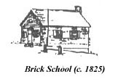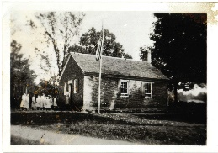
Carol North, Anne Burke and Mary Schweitzer have volunteered to run the 3rd grade school program in the fall, but we are still hoping to find someone who would like to open the Brick School once a month 3rd Sunday in May through the 1st Sunday in Oct. and look after and hopefully add to the Coventry Schools History Collection that Ginney has built. It’s an opportunity to learn some of the Town’s history from a child’s point of view, get to know some of your neighbors and give them access to this place and it’s collections. Contact info.below.

Coventry Historical Society

P.O. Box 534
Coventry, Connecticut 06238

Phone:
860.742.9025

E-Mail:
info@ctcoventryhistoricalsociety.org

The Coventry Historical Society Web Site is located at:
www.ctcoventryhistoricalsociety.org or

Visit us on Facebook
Volunteers will be needed on Sundays at Strong Porter Museum from 11 Am to 2 Pm to park cars and show people the house and outbuildings during the Farmers Market. Visit the market and then stay for a while. CHS Tag Sale June 11 and 12donations welcome, volunteers are welcome!

Coventry Historical Society
P. O. Box 534
Coventry, CT 06238
Executive Board
President………Jim Murphy
860-742-3054
irishbrit0471@att.net
Vice President…. Susan Way susanrway@gmail.com
Treasurer………..Milton Natusch
860-465-9437
Archivist………… Susan Way
860 712 4278
Secretary…….JoAnn Aitkin

Past President...Pat Natusch

Members at Large

Joann Aitkin…………..860-742-9734
Rachel Dawkins……..
Jim Wicks…………. Maintenance
Team works at Strong Porter Wed.
Carol North………….
Executive Board Meetings are held on
The second Thursday of every month, 7:30 pm at the Strong-Porter house. All are welcome.

Become a Member

If you aren’t already a member of the Coventry Historical Society, please consider joining now!

Single Membership $10.00

Family Membership $15.00

Send us your name, address and contact information using one of the methods listed on the left of this page.

Telephone number and email address would be appreciated.

