The Sign Post
March 2018________________________________________________________Vol. 26 No. 1
The Porter Farm
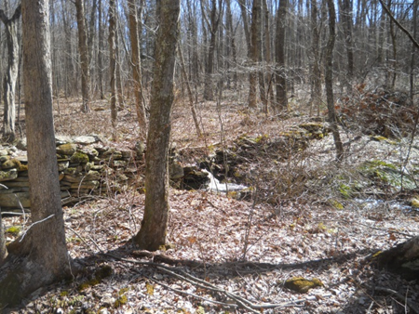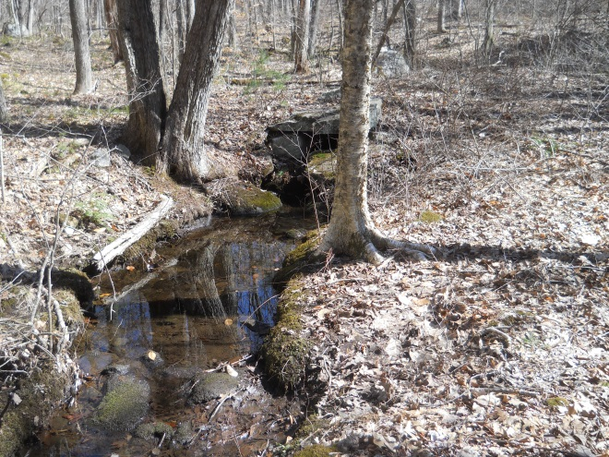
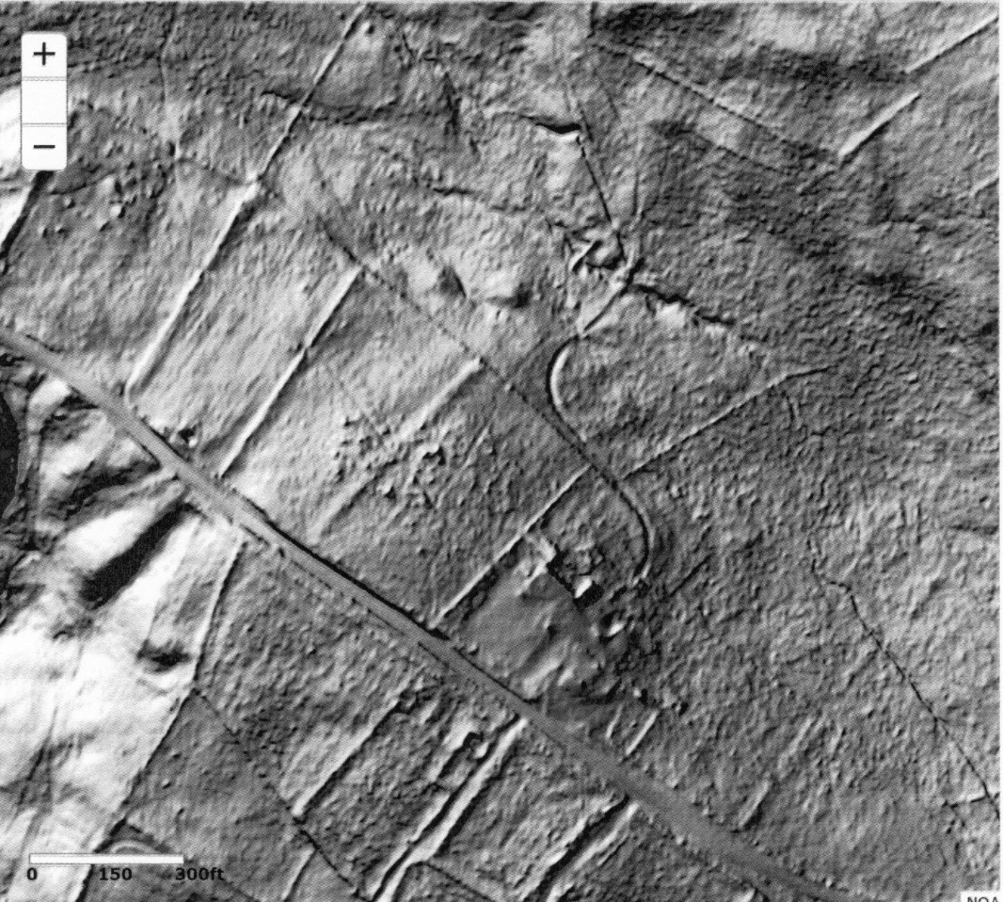
The focus of our Museum at Strong Porter has been the 18th century buildings and our collections of documents, photographs, antique glass, cloth, tools and vehicles. Last spring Steve Marshall drew our attention to what is behind our museum- the rest of the Porter Farm.
When George Dudley Seymour bought the Porter Farm in 1926 it included about 228 acres. His first interest was the restoration of the house.
Steve mentioned to us that he wanted to show us a possible mill site behind Strong Porter that he had come across 20 years ago while planning a Boy Scout event. We planned a walk for the Spring as soon as the weather would allow, but before the undergrowth would hide what we were looking for. Five of us, Steve Marshall, Richard Symonds, Bill Jobbagy, Jim Wicks and Sue Way headed out on a nice day, and followed the small stream that crosses under South St. just east of the Hale Homestead and flows Northwest until we came up behind the big Barn Foundation at Strong Porter where we discovered a deeply worn cart or animal path, which led us to a stone bridge that crosses over a small upper dam and creates a small pond. From that upper pond a raceway or trench leads water away from the stream. Below these features is a second larger dam which would have created a larger pond before it was breached at some point in time. Since that day we have been searching the records for day information that might tell us how these works were used.
In this Satellite photo above provided by NOAA through UCONN Extension Service, you see South St. crossing diagonally in front of Strong Porter House but the computer has removed the trees and the buildings. What stands out clearly is the rock walls surrounding fields, and the old barn foundation. Behind the barn foundation is an S shaped curve which is the old cart path which leads to the stone bridge over the brook. The lower dam can be seen quite clearly, as well as the raceway which is the straight ditch running northwest from the bridge. Notice how clearly you can see the house and barns of the Wright farm on the other side of South St. the Porters and the Wrights and Hales were very close neighbors.
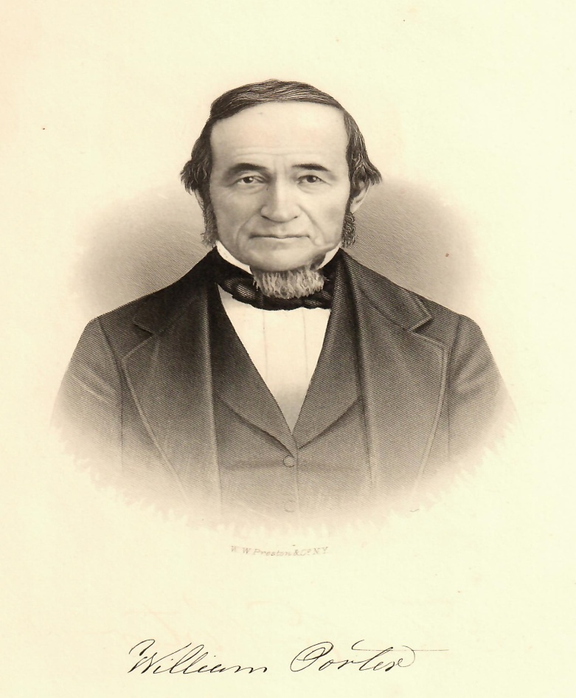
William Porter, born in 1789 was the son of Erastus Porter who was educated at Yale at about the same time as Nathan Hale. Erastus was fatally injured while plowing and died at the age of 28 when his son William was just 2 years old. This information comes to us from Cole’s History of Tolland Co. published in 1888. The book goes on to report that the Porter family had owned the farm since 1735 and that William became a “good agriculturist and his farm was productive and responsive to good treatment. Besides the staple articles, wool, flax and silk were grown and manufactured on the farm until 1842.”
There are number of steps in the production of wool, linen and silk that might have made use of these ponds and perhaps the waterpower that could have been produced. The small valley that surrounds the dams is a rocky area that would have been suited to grazing, but not plowing. The area is almost completely surrounded by rock walls that might have controlled and protected sheep. We are hoping to learn more as our investigation continues and, in the meantime ……………………………………………………
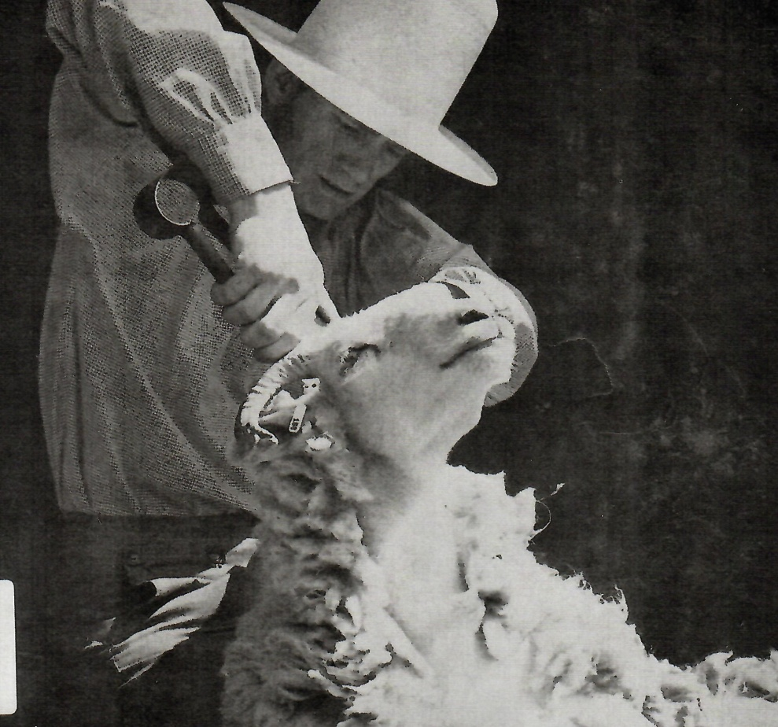
You are invited to take a walk with us through the Porter Farm to see these newly rediscovered features of the Porter Farm, April 8th. We will meet in the Strong Porter parking lot near the barn at 1PM. Please wear good strong walking shoes.
There are many steps between the care and sheering of sheep and the final cloth or felt. In Coventry much felt was used in the making of hats. There are just as many steps in the making of Linen or Homespun from Flax, and in the production of silk. Before the Revolutionary War the production of cloth at home was seen as a step towards independence. When war began trade with England ceased, but families still needed clothing and soldiers needed uniforms. Drawing from Channing & Channing 1969
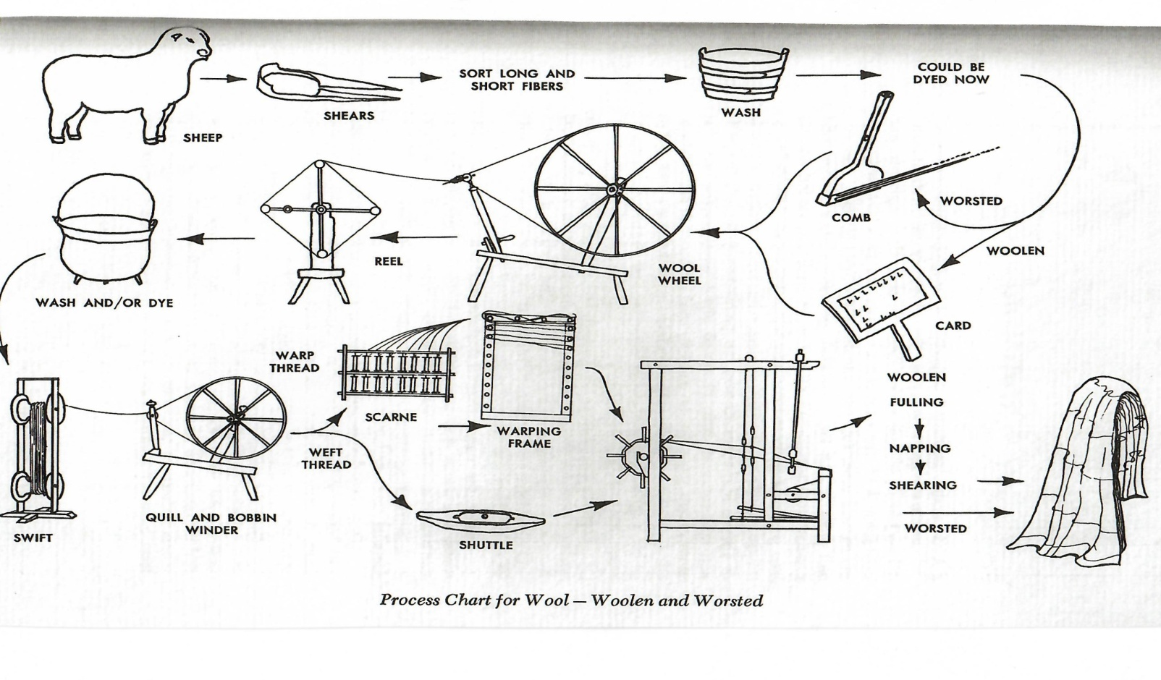
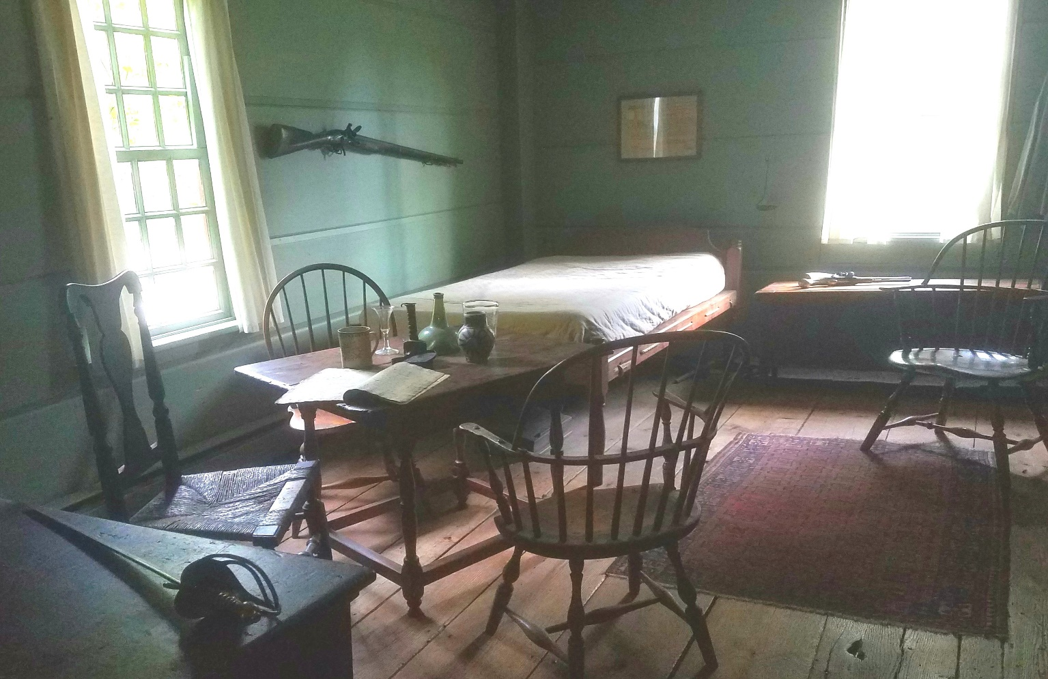
Please save this date – Sunday June 10th, 1:30pm. We are planning a program at Strong Porter.
“What if Muskets could talk?”
Liliana Damascena will show us some of her collection and tell us the stories behind each treasure. This talk will be free for members, & students. A $3 donation is asked for non members.
Finding Aid Project- CHS is participating in a program sponsored by. We have selected 5 collections, and will create Finding Aids which are outlines of what is contained in the collection. These will be submitted to AOL to be posted on their website. Researchers across the country will be able to search these Aids, and will be able to contact us if they locate something they are interested in.
We chose the White/ Jacobson Family collection to work on first. We’ve been organizing and will soon begin writing our outline. There are many very interesting things in this collection, mostly documents, so look for future exhibits and stories that are emerging from boxes of papers.

