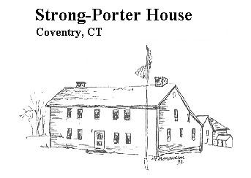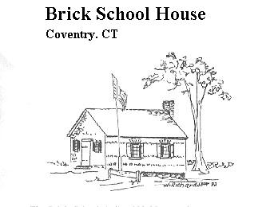
March 2017
Volume 25, Issue 1

Sign Post

Old Gas Stations of Coventry
Come to our March 16th “Stew & Story”!
Coventry has always been a country town. You may be surprised how many
folks embraced the newfangled automobiles that were being produced at the turn of the 20th century as well as everything that went with them. Bill Jobbagy has produced a new booklet that lists and then tells the story of the first cars in Coventry and the “Old Gas Stations of Coventry” that served those cars. He tells us that the first car in town was a Stanley Steamer purchased in 1903 by a foreman at the Silk Mill on Mason St. He goes on to say that by 1912 cars outnumbered wagons and carriages in town! Would you have guessed that? There are other surprising facts and gas stations you never knew about. Come to our March 16th “Stew & Story” 6:30 PM at 2nd Congregational

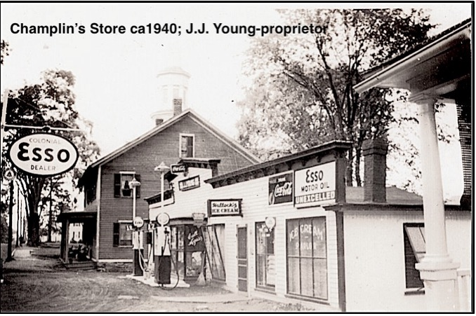

___________________________________________________________________________________________

Above: Steamer Launch at Lake Wangumbaug

Left: Newspaper advertisement for building lots on Lake Wangumbaug, $99.00 and up.

We think very few of you could name all of Coventry’s gas stations. We’re so sure of it that we’d like to give a prize to the person who can come the closest to writing them all down without first consulting Bill’s new booklet. Bring your answers to our March 16th “Stew & Story” program at the 2nd Congregational Church Community Center on Boston Tnpk. 6:30 PM. We’ll have some great Stews (including Vegetarian) Bread, Beverages, and Dessert. Bill will tell us the story with a slide show and we’ll have copies of his booklet available.
It’s easy to imagine the excitement that came with each new car in town along with the amazement of the first sight, sound and first ride. The excitement of those early rides were dampened by the frequent breakdowns. Blacksmiths would have been called on to make the first repairs. There were tools in their shops and they were skilled at repairing wagons and other wheeled vehicles. Fascination with trying to understand and repair the new engines has been with us ever since especially among young men. This is very fortunate for the rest of us
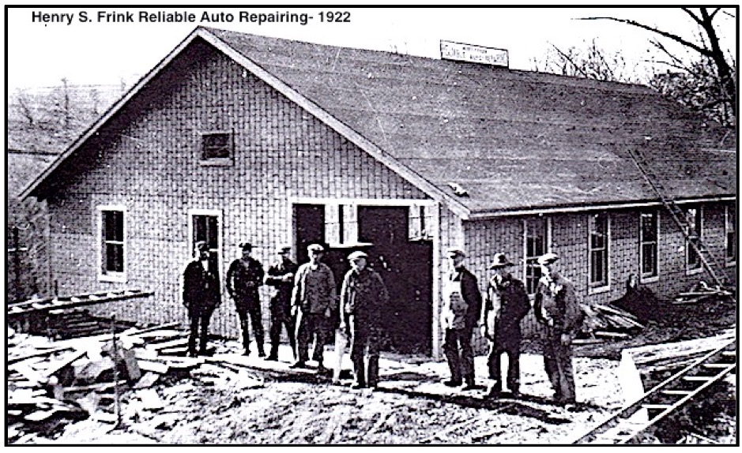
Opening in 1922 Henry Frink’s garage was the first shop in town to specialize in car repair. Eventually he also sold gas and became a Ford dealer. He sold his business to Floyd Wiley in 1945 who operated the business with his brother Robert until 1958. Callahan Oil of Norwich owned it next and brought in a lot of fill to bring the station that stands on this site today next to the Coventry Visitor’s Center up to road level. This site is not only the first service station it is far and away the longest serving as such.

-MANY THANKS TO ALL OUR VOLUNTEERS WHO HELPED TO MAKE OUR 2016 EVENTS AS SUCCESSFUL AS THEY WERE.

Church Community House. We’ll have some great Stews (including vegetarian) Bread, Beverages and Dessert. Bring a mug and a spoon. Please call for a reservation 860 742 9734 and please leave a message a donation of $10.00 is being requested. Copies of Bill’s booklet will be available.
It’s easy to imagine the excitement must have come with each new car in town along with the first sight, sound and first ride. The excitement of those first rides must have been dampened by the frequent breakdowns. Blacksmiths would have been called on to make the first repairs. There were tools in their shops and blacksmiths were skilled in repairing wagons and other wheeled vehicles. Fascination with trying to understand and repair the new engines has been with us ever since, especially among young men. This has worked out well for the rest of us.
Opening in 1922 Henry Frink”s garage was the first in town to specialize in car repair. Eventually he also sold gas and became a Ford and Tire dealer. He sold his business to Floyd Wiley in 1945 who operated the business with his brother Robert until 1958. Callahan Oil of New London owned it next.
On Nov. 16, 1960 Richard Sanborn rented and began operating Sanborn’s Service Station at this location. His son Sandy still operates this station making this far and away the site serving the longest as such. He was 11 years old in 1960. When asked when he started helping out at the station he repeats “11 years old- pumping gas”. It’s always been a family business. In 1969 the family opened Sanborn’s Auto Parts on the other side of Main St. (now Stein’s Antiques and originally Proulx’s Plumbing). It was Sandy’s mother Jessie who ran the auto parts store. That store operated until 2003.

Page 3 Richard and Jessie Sanborn had been working at Pratt & Whitney until the strike of 1957. They never went back. Where did Richard learn to repair cars? It was on the job training!
It’s easy to see why these gas stations and garages became centers of local activity. Once you had purchased an automobile servicing them became ever more important, and of course you had to have gas to use them. Business men soon saw a need and an opportunity, and stepped forward in this brave new world to fill that need, but in a typically Coventry country style.

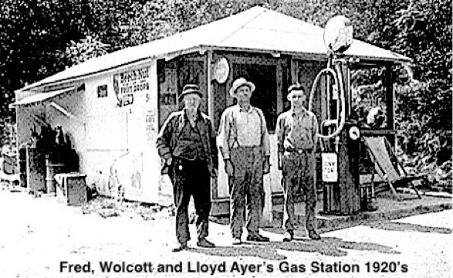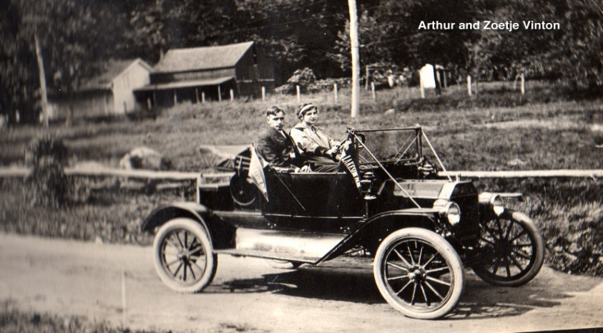

Many of these gas stations sold food, tires, bottled gas, appliances and some provided the opportunity for entertainment. Champlin’s was a barber shop, billiard room and confectionary. Vinton’s sold gas, ice cream and candy and delivered milk, and eventually sold grain, tires, refrigerators and groceries on credit during the depression, and operated a Dance Hall in their barn. When the North Coventry Fire Dept. was formed their 1st fire truck was stored in that barn. (It did not quite fit. They cut a hatch in the back of the building so the ladder could stick out of the building!) Bob Visny says he looked forward to stopping at Strack’s on the way home from school for some candy or a cookie, and a greeting. The days when local taverns were the social and information centers in several sections of Coventry had passed into memory not long before, put out of business along with the Stagecoach lines by the Railroads. There was local news at these stores and local contacts. One and all these gas and service stations provided a variety of services to their neighbors, visitors and strangers, and were not always treated kindly in return.
The most infamous gas station hold-up in town took place in Feb. of 1957 when “Mad Dog” Taborsky and his partner “Meatball” Columbe held up Vinton’s store, site of Dimitri’s restaurant today. Arthur and Zoetje Vinton were robbed and pistol whipped, and left for dead. Taborsky ordered his partner to take the Vinton’s granddaughter out back and shoot her. Columbe could not go through with it and hid the girl, told her to be quiet and shot his gun into the wall. These men were caught and punished. The Vintons were soon back at work as usual in their store!

Coventry Historical Society

P.O. Box 534
Coventry, Connecticut 06238

Phone:
860.742.9025

E-Mail:
info@ctcoventryhistoricalsociety.org

The Coventry Historical Society Web Site is located at:
www.ctcoventryhistoricalsociety.org

Or check out our Facebook Page.
We are planning a Tag & Plant Sale for the 1st weekend in June We’re accepting donations and will make spaces available for $15. Volunteers needed to pot Herbs for sale.
Coventry Historical Society
P. O. Box 534
Coventry, CT 06238
Become a Member

If you aren’t already a member of the Coventry Historical Society, please consider joining now!

Single Membership $15.00

Family Membership $25.00

Send us your name, address and contact information using one of the methods listed on the left of this page.

Telephone number and email address would be appreciated.

Look for the opening of the Brick School House. Strong Porter Museum will open the 2nd weekend in June. Our main exhibit will again be “Old Taverns of Coventry”. If you missed it last year please come by and see it.
Executive Board 2016-7
President…………..Jim Murphy
860-742-3054
irishbrit0471@att.net
Vice President…... JoAnn Aitken
Treasurer…………. Susan Way
860-712- 4278
Archivist………….. Susan Way
susanrway@gmail.com to arrange a visit to the museum or Archives
Secretary & Brick School Docent………..…….Rachel Dawkins
Maintenance……..Jim Wicks
Past President......Pat Natusch
860-465-9437
Members at Large
Milton Natusch
Donna Sliva

Executive Board Meetings are held on
The second Thursday of every month, 7:30 pm at the Strong-Porter house. All are welcome. Anyone interested in joining the Board please contact us.
Volunteers will be needed to help park cars and show exhibits on Sundays. We’re also looking for help with Archives and exhibits.

