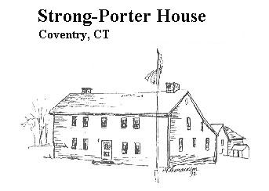  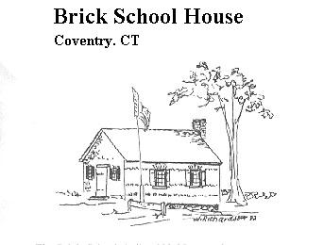

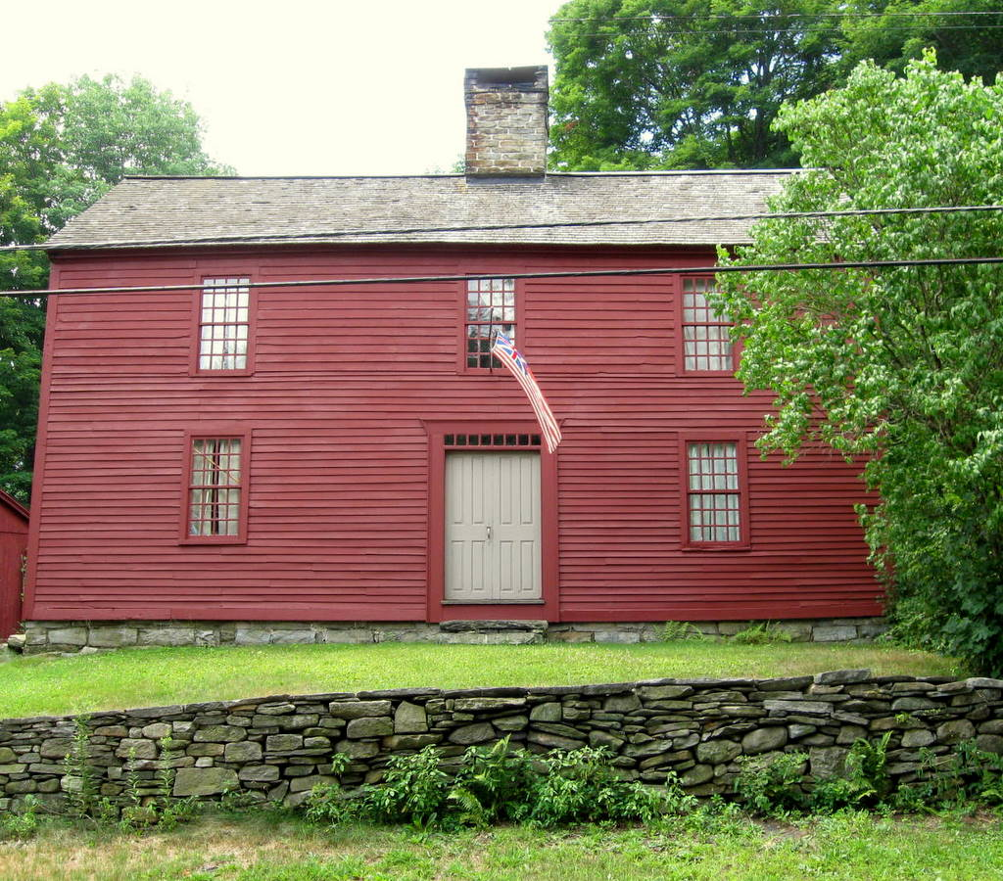**Amos Richardson’s Tavern House** Bill Jobbagy’s research shows that at least 14 buildings in Coventry before 1900 were used as Taverns or Ordinaries, as they were first called. Of these 12 are still standing. Almost all have returned to use as private homes. Some had had been private homes converted to Tavern use, and others were built to be used as a Tavern House.

Amos Richardson Jr. was married in June of 1751 to Ruth Stiles and on a farm given to him by his father he built the Tavern house that still stands on Main St.. This house was restored by the Marshalls and by Liliana Damasceno who now lives there. The east side of the house was built to serve as the family’s home, and the west side to serve as a Tavern. If you look closely you’ll see that the east side of the house (left side of the picture) is larger, the front door not quite centered. The interior of the east side was beautifully finished with paneling and painted for the families use, while the Tavern rooms are lined only with feather edged white pine boards The upstairs chamber room of the Tavern was never painted and has no fireplace, and so in colonial days no heat! The downstairs Tavern room was built with a hidden staircase by its own hearth. The stairs led directly to the basement where liquor and other provisions were stored. The house today looks much as it would have so many years ago.

This salt box house and farm would have been full of activity. Amos served during the French and Indian War and his wife would have been called upon to manage the farm, the Tavern and their young children while he was away. Militia service was required of every able bodied man in the colony, and meetings of officers were held at local taverns on a rotating basis. The other taverns in North Coventry at this time were the Kimball Tavern which stood at the corner of Rt. 44 and today’s Mark Dr.; the Jacob Wilson Tavern which still stands at the west corner of Rt. 44 and Bread & Milk St.; and the Brigham Tavern which still stands on the north side of Rt. 44 just before you cross the Willimantic River into Mansfield Depot. (please see below).

The main road through North Coventry at this time was the Middle Post Road and not yet a turnpike (1799). Stagecoach routes were just beginning to form. Roads were poor and travelers infrequent. The news of the day was often passed on by mail and travelers, as well as

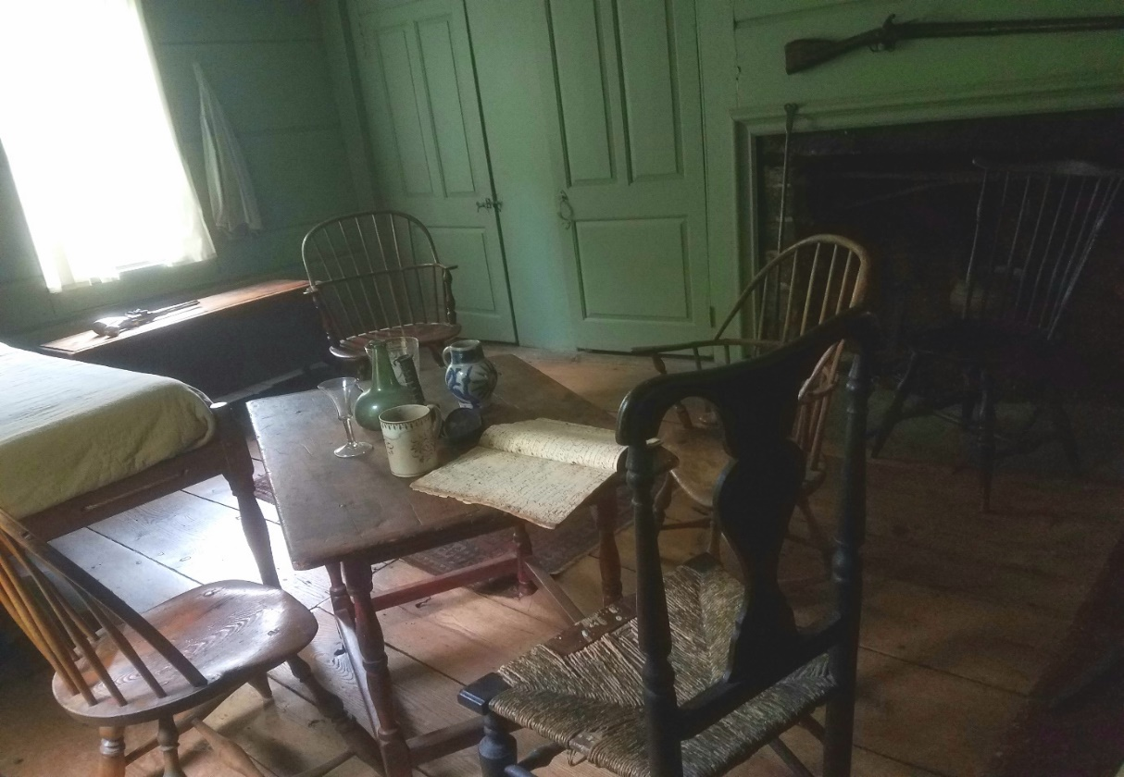stage coach drivers, early newspapers, pamphlets and Sunday sermons. People often came to the taverns to pick up their mail, hear and discuss the latest news and politics. Many tavern keepers were considered to be among the most knowledgeable people in town and were often elected to political office or as officers of the Militia as Amos was. In 1767 he was elected Captain of the 9th Co. of the 5th Regiment of the colony’s Militia. Trouble with England was already brewing, and the people of Coventry were very much involved in the protests against the Stamp Act and other actions taken by the British Government. Amos was a member of the committee appointed to collect donations for the poor of Boston and Charlestown by the people of Coventry which took place after the British closed Boston Harbor to shipping following the Boston Tea Party. Talk around the tavern tables in those days must have been very interesting indeed.

In April of 1775, following the battles of Lexington and Concord a post rider came through Coventry in great haste with the news and 116 men gathered on the green on Ripley Hill Rd. before marching for Boston. Capt. Amos Richardson was among them. In that extraordinary year whole companies of soldiers were marching north to join the siege of Boston. George Washington called for expert riflemen and on August 24th, Capt. Cressup of Maryland with 125 men, 12 horses and 2 wagons spent the night at Capt. Amos Richardson’s Tavern and farm. In her husband’s absence Ruth Richardson and her daughter would have been called upon to prepare the 125 rations that were served. You have to wonder how much notice they were given and how they managed to find enough provisions to feed them all. The History of Tolland County by J.R. Cole says, “Every movement necessary looking to the clothing of the soldiers who enlisted from Coventry, to the maintenance of their families and to the encouragement of the cause of liberty was made by the citizens of this town. Not only did the town furnish clothing and men, but also a supply of beef and other provisions for the Army.” This was the early formation of a network of suppliers that would become part of the Commissary Dept. that would give the State its reputation as “The Provision State” during the Revolutionary War, and in which Coventry was very much involved.

{Background information and some specific facts also came from home owners and several books; The Roots of Coventry by Betty Brook Messier and Janet Sutherland Aronson 1987; Stagecoach and Tavern Days by Alice Morse Earle 1901; Post Roads & Iron Horses by Richard Deluca; The Kings Best Highway by Eric Jaffe 2010; Births Marriages Baptisms and Deaths by Susan Whitney Dimock 1897}

Three days later, Aug. 27, 1775, 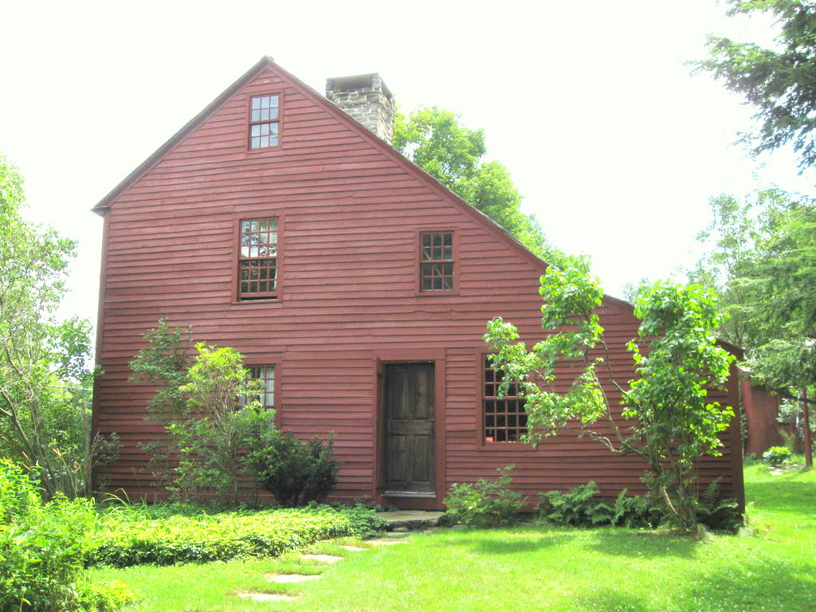Uriah Brigham served 100 meals to Capt. Cluggage’s company of Pennsylvania riflemen at his Tavern. Both taverns submitted bills for meals served and for damages to their buildings! The Brigham Taverns sign was “shot to pieces!! (from “March of the Rifle Battalions Across Conn. August 1775”a booklet by F.C.Bissell, CT State Library) It’s not difficult to imagine the concern, excitement and activity that must have Filled the Town at that time.

Please join us Sunday Nov. 12th at Strong Porter

To see the exhibit and hear the talk about

The Old Taverns of Coventry

Then we’ll send you off to tour the Amos Richardson, Uriah Brigham and Daniel Rust Taverns.

Please call for a reservation at 1PM, 2PM, or 3PM

at 860 742 6295 during the day and at 860 712 4278 during the evening.

Requested donation $15 for members $25 for non-members.

This will include a copy of Bill Jobbagy’s booklet

“Early Hotels and Taverns of Coventry”

**On October 22 we are planning a**

**Mill Walk through South Coventry Village**

**Beginning at 1 PM in the parking lot of the Welles Agency. Come and see what’s new in the Village, and the many historic treasures.**

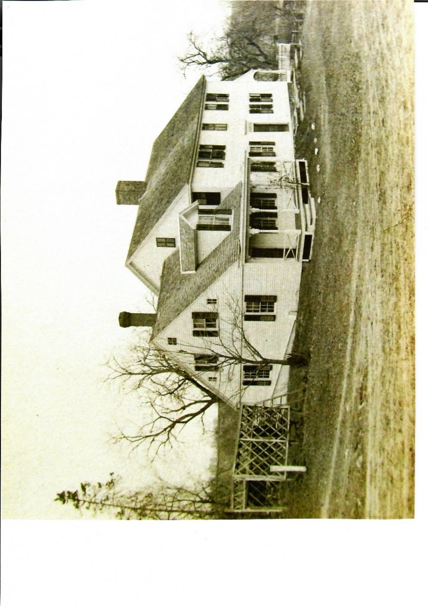The oldest section of the **Brigham Tavern** is behind what you see on the road and was built in 1725 by Jonathan Weeks. Uriah Brigham is known to have been Tavern Keeper in 1775 when Capt. Cluggage stopped there with his Pennsylvania riflemen. Uriah died in 1777 and his son Gershom Brigham became owner and Tavern Keeper. In 1778 he built the front section of the house to accommodate his growing business and included a ballroom on the second floor. The most exciting day in the life of this Tavern must have been the day that George Washington stopped there for breakfast during his New England Tour Nov. 9, 1789.

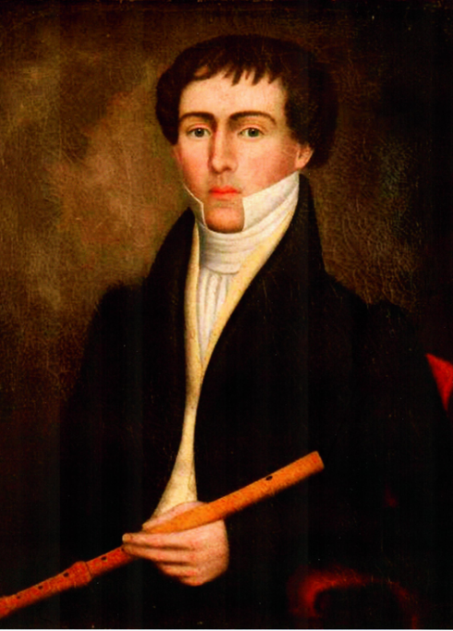 This Tour took place during the 1st Congressional recess under the new Federal Government. Traveling through NY, CT, Mass and NH he visited “60 towns stopping along the way to visit factories, with farmers and partake in celebratory festivities.” It was part of a larger plan to visit all the states and rally support for the new Constitution which at the time had been ratified by only 11 states. He was accompanied by his personal secretaries Major William Jackson and Tobias Lear and six of his slaves. He traveled by coach and usually “just before entering a town he left the carriage and rode astride his great white charger usually accompanied by local Militia.” He would meet with local politicians, and attend local churches on Sundays. “He refused to stay in private homes and instead insisted on paying for lodging and meals at taverns and public houses.” (Catherine Treesh, “New England Tour” mountvernon.org/digital encyclopedia) It’s not difficult to imagine the excitement of that day.

Gershom and Anna (Parker) Brigham had no children. Their niece Anna Brigham married Roderick Dimock in 1806, and the 1810 and 1820 census records lists Roderick Dimock right next to Gershom Brigham. In 1810 Gershom would have been 61 years old and may have already passed responsibility for the Tavern to Roderick and Anna Dimock. The 1850 Census shows Roderick Dimock to be the Inn Keeper and this is the last mention we have found of the use of the house as a Tavern.

Roderick Dimock 1784-1852

as painted by Erastus Salisbury Field (G.D.Seymour)

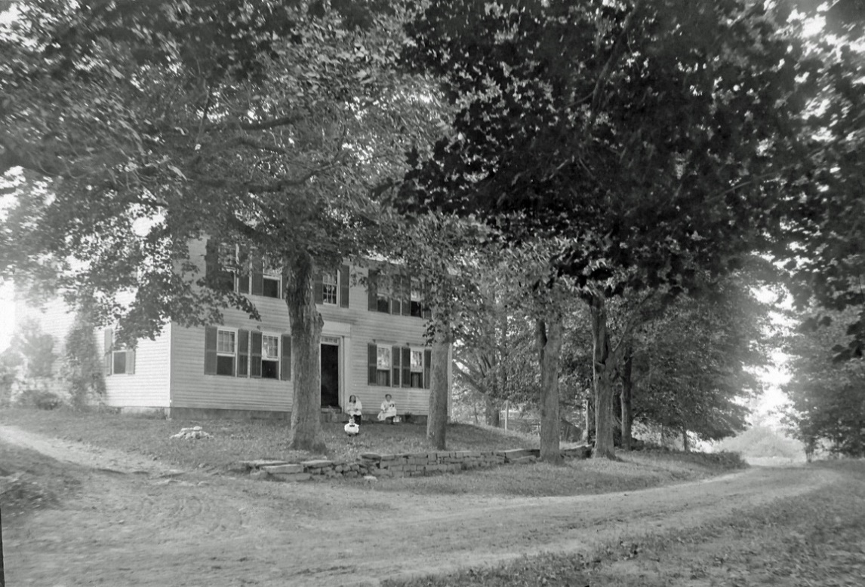

**Bird in Hand Tavern**

**Circa 1920 photo**

**by Charles Coombs**

The **Rose or Bird in Hand Tavern** is known to us today as the Daniel Rust Bed & Breakfast at 2011 Main St. It was built in 1731 by Daniel Rust. The house was sold Jehiel Rose, a prosperous farmer about 1748. Jehiel Rose Sr. died in 1773 and the house passed to his son Jehiel Rose Jr. who married a neighbor Mary Ripley. He opened the house as the Bird in Hand Tavern about 1800. Jehiel Rose Jr. died in 1813 and his sons Horace and Roderick continued as Innkeepers until the death of their mother Mary Rose in 1823.

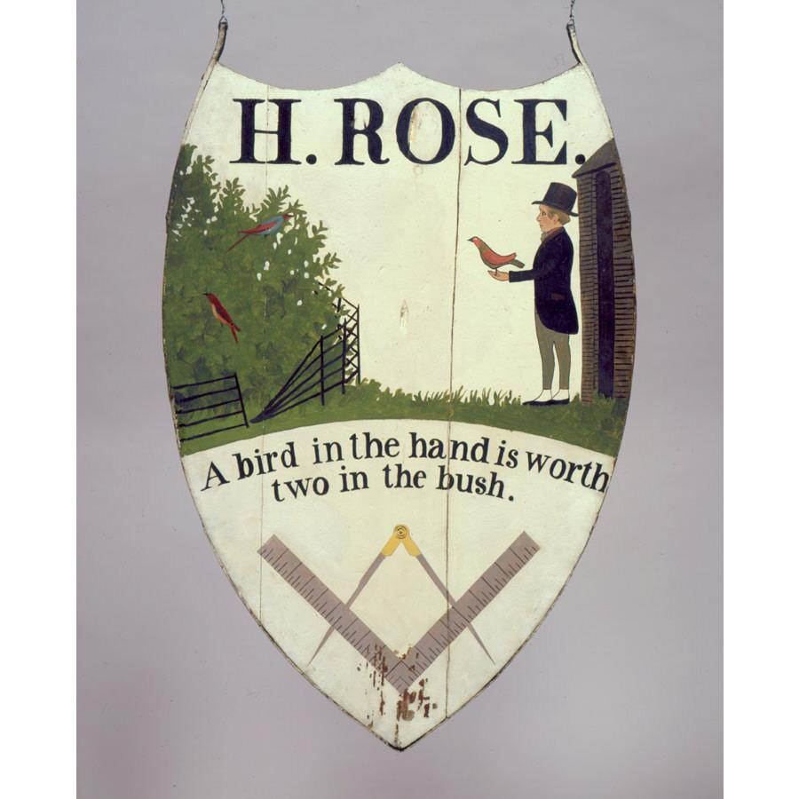 The Bird in Hand Tavern sign is in the collection of the CT Historical Society and is attributed to Harlan Page, an itinerant preacher and painter of some note born in Coventry. The Masonic symbol at the bottoms tells us this organization met here.

This now was tavern keeping in a different era. The Tolland Turnpike was completed from Windham through South Coventry village in 1808, and just after passing the Bird in Hand it continued straight on through what is now woods to Sam Green Rd. where it met up with the Boston Tnpk. With the improvement of roads by turnpike companies and the Concord stagecoach travel increased and stagecoach lines flourished. We don’t yet have direct evidence that the Bird in Hand was a stagecoach stop, but we have rediscovered an 1887 design drawing for a bridge they call “The Stage Road Bridge”. Research has proven that this was the bridge that crosses the Willimantic on today’s Rt. 32. A stage coach connection between Windham and Coventry and towns north on the Tolland Turnpike seems likely.

#### Coventry Historical Society

P.O. Box 534

Coventry, Connecticut 06238

**E-Mail:** [info@ctcoventryhistoricalsociety.org](mailto:%7Cinfo@CTCoventryhistoricalsociety.org)

CHS Website: [www.ctcoventryhistoricalsociety.org](http://www.ctcoventryhistoricalsociety.org)

Facebook: <https://www.facebook.com/coventryhistory/>

|  |  |  |
| --- | --- | --- |
| **Executive Board 2017-8** | | |
| **President** | Jim Murphy | 860-742-3054  [irishbrit0471@att.net](mailto:irishbrit0471@att.net) |
| **Vice President** | Vacant |  |
| **Treasurer** | Susan Way | 860-712- 4278 |
| **Archivist** | Susan Way | susanrway@gmail.com |
| **Secretary** | Rachel Dawkins |  |
| **Members at Large** | Bill Jobbagy |  |
|  | Donna Sliva |  |
|  | Liliana Damasceno |  |
|  | JoAnn Aitken |  |
|  | Jim Wicks | Maintenance |

Executive Board Meetings are held on the second Thursday of every month, 7:30 pm at the Strong-Porter house. All are welcome.

**Become a Member**

If you are not a member of the Coventry Historical Society, please consider joining!

Single Membership $15.00

Family Membership $25.00

Send name, address and contact information using one of the methods listed on the left of this page.

Telephone andemail would be appreciated.

**Please remember to send in your membership renewal!!**

*Coventry Historical Society*

*P. O. Box 534*

*Coventry, CT 06238*