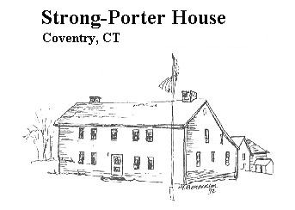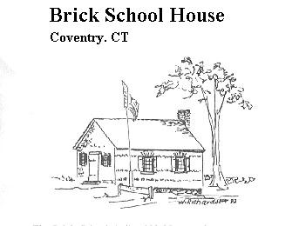
March 2019
Volume 27, Issue 1

Sign Post

Please join us on March 21st for our annual Stew & Story at the Community House, 2nd Congregational Church on the Boston Tnpk.
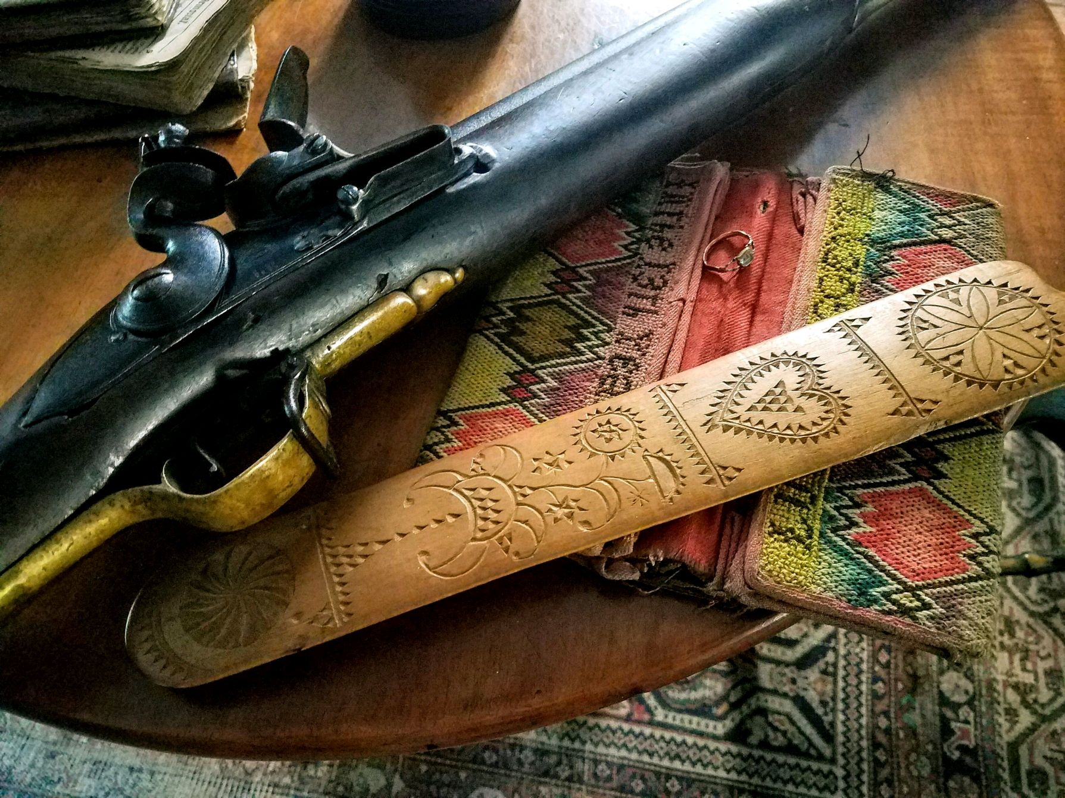

Photo by Liliana Damasceno
We’ll be serving a dinner featuring a variety of Stews, including vegetarian stew with homemade breads, beverages and dessert beginning at 6 PM. The cost of the program and meal will be $8.00 for members, $10.00 for non-members. For our volunteer stew makers there is no charge. Please call for Reservations 860-742-7277. Please bring a mug and a spoon. Everything else will be provided. The Stories will begin at 7:30, and this year are titled….
Every Object has a History…
What if 18th century Items could tell us Theirs? presented by Liliana Damasceno, who was born in Brazil, but has lived in Coventry for 20 years and has been fascinated with colonial American antiques for most of her life.
The Morgans of Coventry
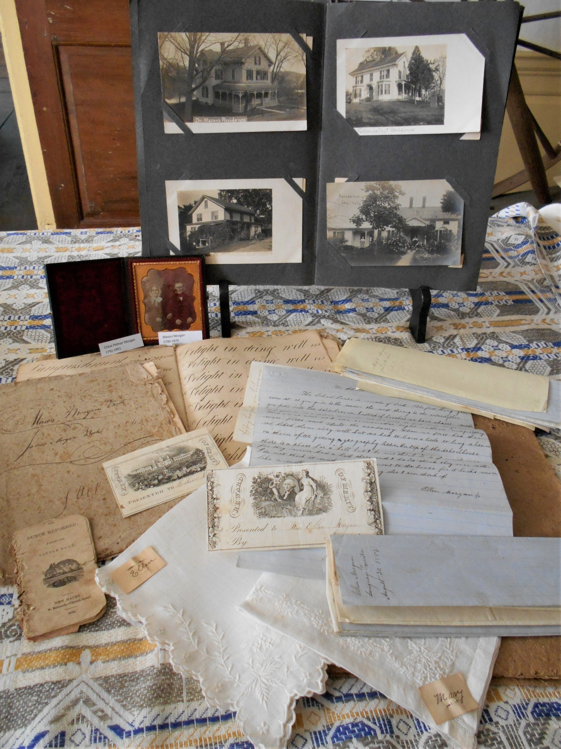
We received a 2nd installment of a donation of items from Mary Miller Chapman a descendant of the Morgan family of Coventry. The 1st installment had come to us several years ago from her mother Mary (Jamie) Miller. Jamie’s great, great grandparents E. Perry & Mary (Morgan) Packer moved to California with their young daughter 1875-78. It has been almost 150 years since this family took the long train ride to Santa Monica and now their descendants have sent us boxes of fascinating Coventry related items, pieces of Town history, and we are delighted to hear that more is coming. This branch of the Morgan family lived in Coventry for four generations and played many important economic and leadership roles in Church and Town government. They farmed, raised their children, attended local schools, worked in and ran the local mills, played flute for the local militia as well as violin, and cello in church. Mason and his son James led the choir at 1st church, James for 60 years.
Photo by Susan Way
During the 1800’s, economic life in a small New England mill village could be very prosperous, but could also be very uncertain. A drought meant too little water and the water powered mills could not run. A flood on the other hand could damage mill works, dams, buildings and equipment, and shut down operations for a time. Fires, which were all too frequent could and often did burn down entire mills. Raw materials were sometimes in short supply, at other times demand for a product might slow down and sometimes close a business for a season or permanently.
National and international trends were felt here in Coventry as well. The Civil War put Coventry’s flannel Hat makers out of business, but gave new purpose to the Cartridge making industry. “The panic of 1873 was a financial crisis that triggered depression in Europe and North America that lasted from 1873 until 1879, and even longer in some countries (France and Britain). In Britain, for example it started two decades of stagnation known as the ‘Long Depression’ that weakened the country’s economic leadership. ( apparently triggered by the opening of the Panama Canal) In the United States the panic was known as the ‘Great Depression’ until events of the early 30’s set a new standard.” (Wikipedia)
Every business and boarding house in a small village felt the effects of such disruptions as mill workers lost jobs, and often had to go where they could find work. E. Perry Packer was a successful Country Store owner near the corner of Woods Lane on Main St. who married Mary Ellen Morgan daughter of James S. and Mary (Bailey) Morgan in 1867. Mr. Packer was well established and served as Town Clerk for a time. However, in 1875 he was forced to declare bankruptcy, and put his affairs in the hands of his brother-in-law William F. Sweet and E.G. Huntington. He then left for California. He changed the family name there to Chapin for a fresh start and in 1878 his wife and daughter joined him, and they did prosper there. This was not an uncommon story in that era when a fresh start in the West was so possible. Certainly a fresh start is something America has provided for many people. Susan Way
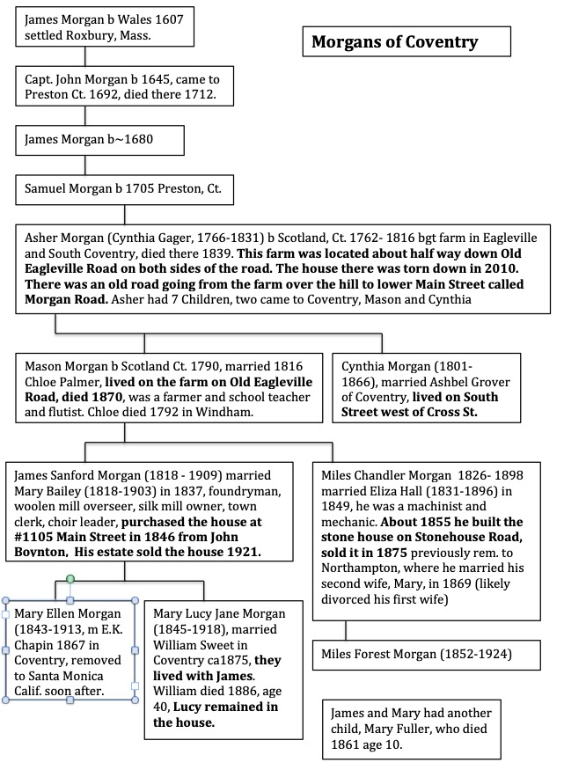
Morgan family tree compiled by Bill Jobbagy- space did not allow us to include all siblings
Brick School News
Kenny Boland’s Eagle Scout Project 2018
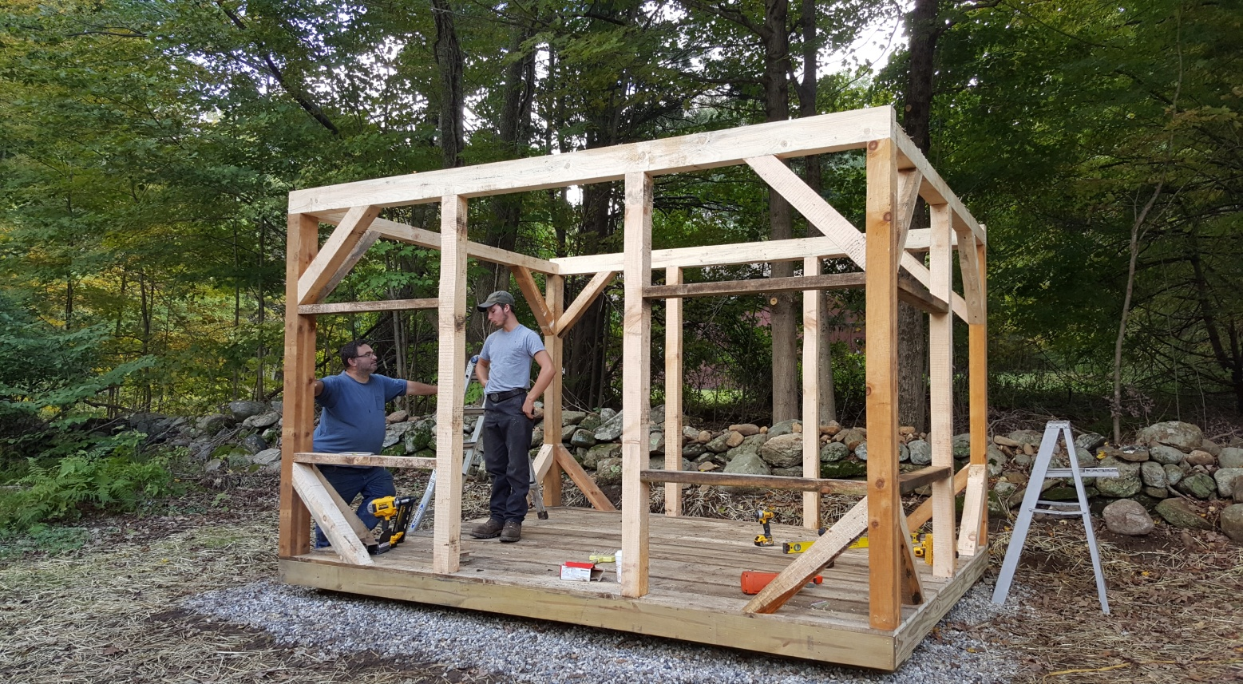
Several years back the Wood Shed and Outhouses at our one room Brick School House at the corner of Merrow Rd. and Goose Ln. was crushed by a falling tree. In 2018 Eagle Scout Kenny Boland designed and cut lumber with his own saw mill from logs that came from property right up the street for this replacement shed. With the help of family and friends he completed the project in the fall. It will be used for storage of benches and other items related to the Brick School programs. Originally residents in this School District could pay their School Tax with a load of wood. Bob Visny remembers getting to school early in the morning to start the fire in the pot bellied stove. We want to extend our thanks to Kenny and his crew.
Photo by Jim Wicks
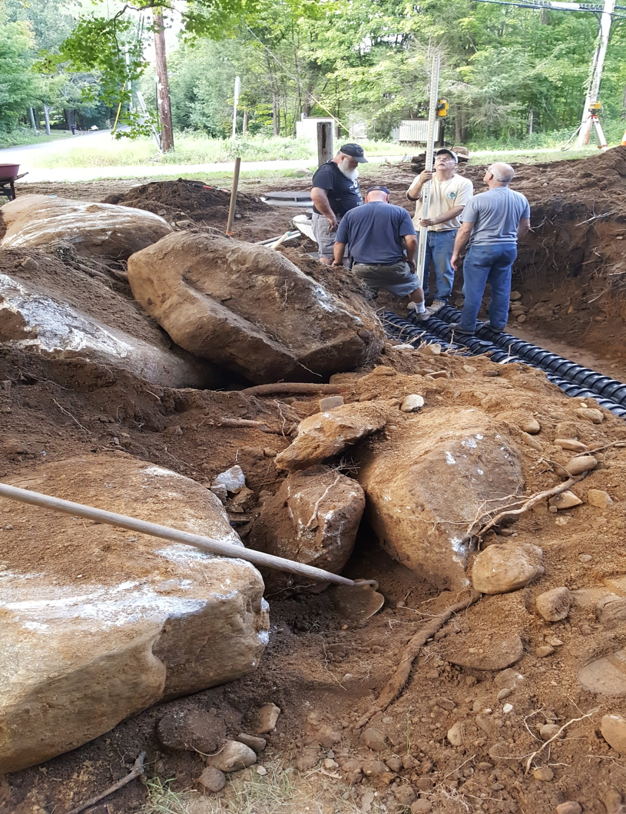
Brick School Plumbing upgrade Jim Wick’s crew of volunteers was led by engineer Randy Becker, and included Tom Burke, the Boland Family - Kenny Sr, Kenny Jr., Kristyjo and Mariah, Jim Sposito, Byron Hill, Brian Wicks, Ed Bzdrya and Jeff Polhemus. As you can see they had to contend with Coventry’s most abundant natural resource- rocks. The project was completed using funds donated for the purpose by Brick School graduates. Volunteers made it all possible and we thank them.
Please Join Us on June 31st
Mary Chapman and some of her family are coming to visit and we’re planning a picnic and Morgan family exhibit at the Brick School to celebrate. So many of the items in the collection pictured above are school related it seemed only fitting to create a display there. We’d also like to give you the opportunity to see the reconstructed shed behind the school, completed last fall by Eagle Scout Kenny Boland and to hear about the other improvements to the school organized by Jim Wicks and his crew of Volunteers led by engineer Randy Becker. Details will be sent out as we approach the end of June.
Photo by Jim Wicks
MORE DONATIONS FROM OUR MEMBERS
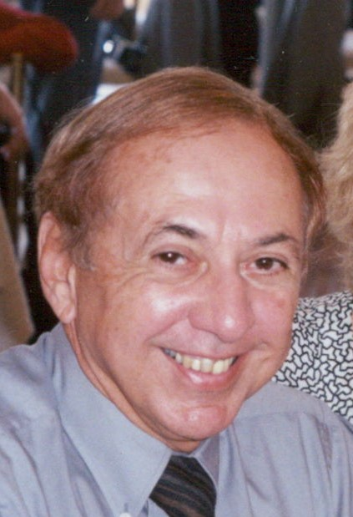
We’re happy to announce that we have received two bequests in the last year. The first came to us from the estate of Arthur Albro in the amount of $3000. A CHS member Arthur and his wife spent summers at Lake Wangumbaug. Their home is in Garden City, NY. Some searching in Census records revealed that Arthur and his father Herman R. Albro were born in N.Y., but Arthur’s grandfather Herman H. Albro, and his great grandfather Henry Albro were born in Coventry, and are buried in the Nathan Hale Cemetery.
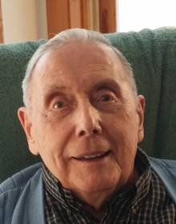
The second bequest in the amount of $5100 came from the estate of Nelson Bearce, a long time CHS member and volunteer known as Chic to his family & friends. He was born in Maine in 1919. He worked as a machinist at Pratt & Whitey, served in the Navy during WWII, then went back to work at P & W until he had saved enough to start his own machine shop in Coventry. CHS has one of his account books in our Archives. Chic lived in Coventry for 70 years. He served as the Town’s Sexton for many years, and was involved in the life of the town in many ways. Chic passed on in March of 2017.
Both bequests have been placed in CD accounts while we make plans for their future use. One of our priorities is safe storage for our growing Archives.
****************************************************
Please Welcome new Board members Anne Burke, Steve Marshall, Dan Gorka and Paul Corey. These are volunteers who are already helping in many ways. If you would like to volunteer, please contact us through our website, Facebook page, by mail or phone. Please see page 6 for contact information.
Please support our new advertisers!
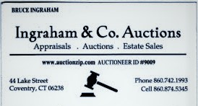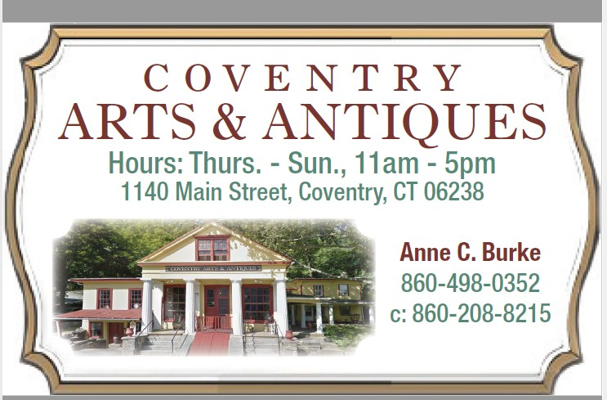

Coventry Historical Society
P.O. Box 534
Coventry, Connecticut 06238
E-Mail: info@ctcoventryhistoricalsociety.org
CHS Website: www.ctcoventryhistoricalsociety.org
Facebook: https://www.facebook.com/coventryhistory/
Executive Board 2018-19 |  |  | Become a Member  If you are not a member of the Coventry Historical Society, please consider joining!  Single Membership $15.00  Family Membership $25.00  Send name, address and contact information using one of the methods listed above. Telephone and email would be appreciated.  Questions, comments and corrections on this issue or suggestions for future issues can be sent to susanrway@gmail.com.
President | Jim Murphy | 860-742-3054  irishbrit0471@att.net
Vice President | Vacant
Secretary | Rachel Dawkins | 860-742-7277
Treasurer | Susan Way | 860-712- 4278
Archivist | Susan Way | susanrway@gmail.com
Members at Large | Anne Burke  Paul Corey  Liliana Damasceno  Dan Gorka  Bill Jobbagy  Steve Marshall  Donna Sliva  Jim Wicks | 860-874-2346 Maintenance
Executive Board Meetings are held on the second Thursday of every month, 7:30 pm at the Strong-Porter house. All are welcome.

Coventry Historical Society
P. O. Box 534
Coventry, CT 06238

